SBT Failover Mechanism and Tests

July 10, 2001

Table of Contents
Table of Contents i
Introduction 1
SBT Components 1
Presentation Services 1
Application Services 1
Business Services 2
External Integration Services 2
Infrastructure Services 2
Infrastructure Failover Tests 3
Simulated Test Types 4
How to Interpret the Locator Log 4
Process FailOver Tests 6
Infrastructure Processes on Global Cluster 6
Infrastructure Proxies on Front Ends 18
Sync/Async Failure Handling Mechanism 27
Scenario #1: Primary ACTIVE and Secondary in DISCARDING state 27
Scenario #2: Primary Failure and Secondary in DISCARDING state 28
Scenario #3: Primary Failure and Secondary in ACTIVE state 29
Scenario #4: Primary Proxy Failure and Secondary Proxy in ACTIVE state 30
Application Failover Mechanism 31
IdServer, GlobalServer, TradeServer, ExtTradeServer, StatusServer, TipsAdapter, TpfAdapter, TpfGlobalAdapter, CtmAdapter, MembershipAdapter 32
Frontend 32
Client Application Server (CAS) 32
SMS Server 32
Testing Application Failover 32
IdServer 33
GlobalServer 33
TradeServer 34
ExtTradeServer 34
Status Server 34
Membership Adapter 34
TipsAdapter & TpfGlobalAdapter (Global Server) 35
TpfAdapter & CtmAdapter (Business Server) 35
SMSServer 36
Frontend 37
Oracle Failover Tests 38
Interface Repository and Locator 39
Central Repository and Central Logging Server 39
Publish-Subscribe Failover Mechanism 40
RTserver Failover 40
SmartCache Failover 41
Distribution Node Failover and Filter Recovery 44
Guardian Failover 47
LDAP Failover Tests 51
LDAP Instance Failure 51
Testing External Failures 52
Infrastructure Component Failures 52
Testing Oracle Failures 52
CDB Failover 53
SBT Replication after Failover from prdcq01a to prdcq01b ( CDB ) 54
CAS Failover 56
CAS Frontend Failure Testing 56
CAS Infrastructure Failure Testing 58
CAS Server Failure Testing 59
ACAS Failover 60
ACAS Frontend Failure Testing 60
ACAS Infrastructure Failure Testing 62
ACAS Server Failure Testing 62

Introduction
This document addresses failure mechanism and tests for the Screen-Based Trading system. Included in the document are SBT component descriptions, scenarios for sync/async failure handling, simulated test types and failover tests.

SBT Components
This section provides a high-level description of the SBT components. The diagram below shows the top-level logical structure and context of the SBT System.

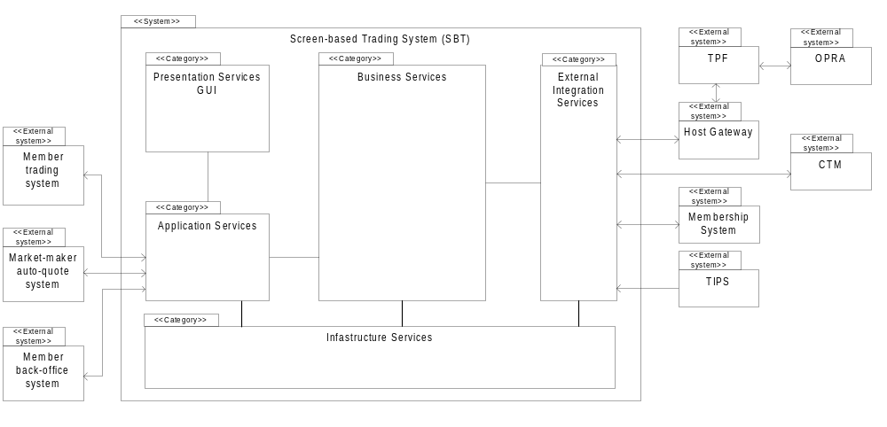

The SBT System is comprised of the following five logical packages of functionality.

- Presentation Services (GUI)
- Application Services (Client Application Server, Gateway)
- Business Services
- External Integration Services
- Infrastructure Services

Presentation Services
The Presentation Services (GUI) package is constituted by applications that interact with the SBT system via the CBOE Member Interface (CMI) API described later. There are two types of client applications, those that provide a GUI to allow user interaction with the system directly and applications that automate trading functions.

Application Services
The Application Services package contains subordinate packages that forward requests initiated by human or automated actors, to be executed by the appropriate Business Services package(s). In addition, the Application Services packages maintain instantaneously-updated views that reflect the prevailing state of each actor’s information in the Business Services package.

Business Services
The Business Services package contains the core functionality of the SBT system. It includes components that correspond to the key business object model entities of screen-based trading such as members, orders, books, products, quotes, et cetera. In addition, it includes components to administer and operate the SBT system.

External Integration Services
The External Integration Services package consists of adapters that map the interaction paradigms of external systems to the ones in the SBT system architecture.

Infrastructure Services
The Infrastructure Services package contains Commercial Off-the-Shelf Software (COSS) and extended infrastructure services that provide enterprise-wide support to CBOE systems.

Infrastructure Failover Tests
The highlighted processes in the diagram below are affected by Infrastructure failover tests.
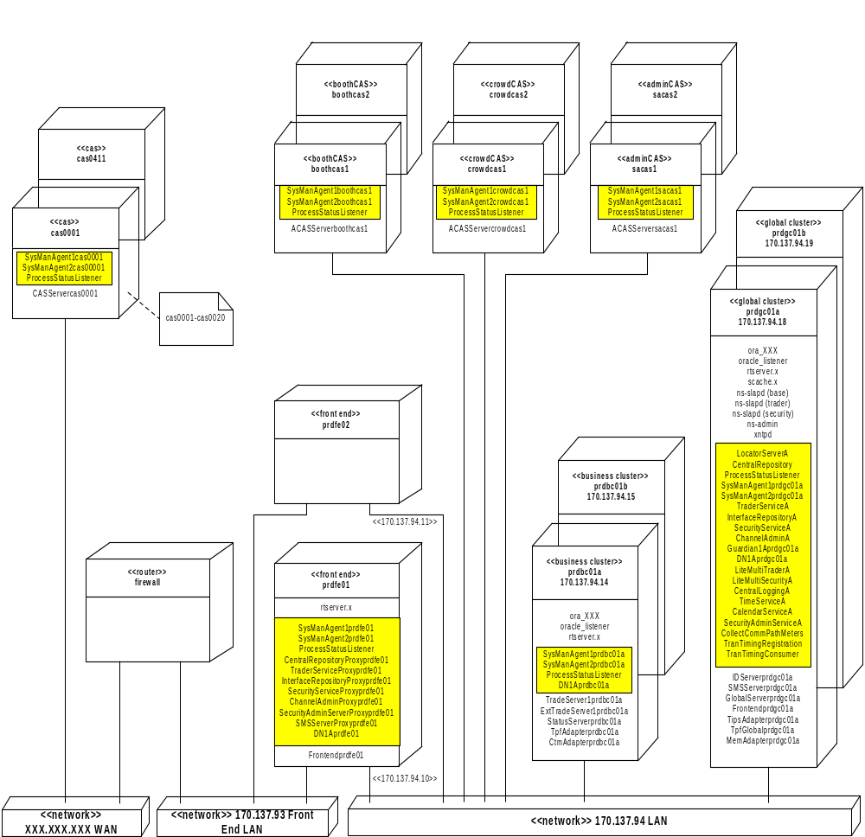

Simulated Test Types

- Type 1
Type 1 tests include changing the POA State of the Process from ACTIVE → DISCARDING and DISCARDING→ ACTIVE.

Case 1:
Using Signals (SIGHUP and SIGINT) to change the POA State.
SIGHUP (kill –1 pid) transitions the POA state from A→D and
SIGINT (kill –2 pid ) transitions the POA state from D→A .
Case 2:
Using SysMan Command Console to transition the POA State.
Case 3:
Using adminRequest (for Application processes)

- Type 2

Case 1:
Simulating Heavy Loads or High Traffic Allowing in the Flow Control
Logic to kick in.
Case 2:
Explicitly crashing or killing a Process.

- Type 3

Case 1:
Box failure
Case 2:
Some unlikely failure scenarios. Ex. n/w card failure, host-name resolution etc.

How to Interpret the Locator Log
- Where to look for locator Logs?

prdgc01a: ( Primary Locator)
- rlogin ( telnet ) to prdgc01a as infrap.
- cd log; tail –f ProdLocatorServerA.out

prdgc01b: (Backup Locator)

- rlogin ( telnet ) to prdgc01b as infrap.
- cd log; tail –f ProdLocatorServerB.out

- Receiving Locate Request From the Client
Serve Locate Request
/RemoteOrbName/:/PoaName//[hostname|PortNum|OrbName]

RemoteOrbName is the OrbName of the client, which has sent the Locate Request to the Locator.
PoaName, PortNum and OrbName give the info of the server, which the client is trying, to Locate.
Ex:

<DEBUG> < Wed 2001/02/07 14:55:40:62 > → Time Stamp at which the Locate Request Came in
Serve Locate Request
/devinfra2505TestTraderFacade: /TradingService//[devinfra2|18026|devinfra2505TraderServiceA]

ORB Name of the trader utility client
POA Name for the Trader Service

Host and Port on which Trader Service is running on

ORB Name of the Trader Service

- Pinging the Original Server for which the Locate Request is being served..
.
<DEBUG> < Wed 2001/02/07 14:55:40:62 >

Ping object: /TradingService//[devinfra2|18026|devinfra2505TraderServiceA]

(The Locator pings the original server to make sure that the Server is down)
.
<DEBUG> < Wed 2001/02/07 14:55:40:62 >
Executing ping: /TradingService//[devinfra2|18026|devinfra2505TraderServiceA]
Wed Feb 7 14:55:40.631 2001
TIOP TRANSPORT ERROR: File[/vobs/dte/MessagingSystem/TIOPTransport/BindManager.cc ] Line[511] Thread[22]Unable to connect to server(tcp:devinfra2:18026).
<SYS-ALARM> < Wed 2001/02/07 14:55:40:63 > org.omg.CORBA.COMM_FAILURE:
TIOP TRANSPORT ERROR: File[/vobs/dte/MessagingSystem/TIOPTransport/BindManager.cc ] Line[511] Thread[22]Unable to connect to server(tcp:devinfra2:18026). minor code: 0 completed: No

(The above Error indicated that the Locate Request being served is unreachable)

- Finding other entry in the Locator with the same POA name and ping it
.
<DEBUG> < Wed 2001/02/07 14:55:40:64>
/TradingService//[devinfra2|18026|devinfra2505TraderServiceA] is not alive, try next one
<DEBUG> < Wed 2001/02/07 14:55:40:64 >
Ping object: /TradingService//[devinfra2|20051|devinfra2505TraderServiceB]
<DEBUG> < Wed 2001/02/07 14:55:40:65 >
Executing ping: /TradingService//[devinfra2|20051|devinfra2505TraderServiceB]
<DEBUG> < Wed 2001/02/07 14:55:40:69 >
Ping reply NOT NULL: /TradingService//[devinfra2|20051|devinfra2505TraderServiceB]
<DEBUG> < Wed 2001/02/07 14:55:40:70 >
OBJECT WAS FOUND: /TradingService//[devinfra2|20051|devinfra2505TraderServiceB]
<DEBUG> < Wed 2001/02/07 14:55:40:70 >
/TradingService//[devinfra2|20051|devinfra2505TraderServiceB] is Alive

(The Locator found the entry for the Trader Service on the B box and pinged the server. The Secondary Trader Service is alive )

- Locate Reply Status

<DEBUG> < Wed 2001/02/07 14:55:40:70 >
Reply status: OBJECT FORWARD : /TradingService//[devinfra2|20051|devinfra2505TraderServiceB]
.
(The Locate Reply Status is set to OBJECT_FORWARD, which indicates that the request is being routed to a different server process)

- Sending Back Locate Reply to the Client.

Sending back LocateReply to remoteOrb: /RemoteOrbName requestID: n
Ex:
<DEBUG> < Wed 2001/02/07 14:55:40:62 > → Time Stamp at which the Locate Reply was sent back
Sending back LocateReply to remoteOrb: /devinfra2505TestTraderFacade requestID: 0

ORB Name of the client, which has sent the Locate Request.

Request Number on the Connection between the Client and the Locator.

Process FailOver Tests

Infrastructure Processes on Global Cluster

All the Infrastructure Processes running on the Global Clusters except for SysMan Agent and Central Repository have a Bind Order Policy of TOFT. (Target On First Try).

Note: There would be only one Central Repository For this release.

Trader Service

Mechanism:

Automatic switching to the backup process occurs using Locator in all the cases (see the Simulated Test Types, page 5) but for Type 2 (case 1) and in some cases of Type 3 (case 2). Type 2 (case 1) is the Flow Control Situation, which indicates a server with heavy load, and a TRANSIENT Exception is propagated to the Application. Here is an Instance of Type 3 (case 2) in which switching does not occur:
FrontEnd tries to communicate with the Trade Server on a Business Cluster (prdbc01a) and if the FrontEnd is not able to resolve the host name (prdbc01a) it gets a COMM_FAILURE from the Native Layer and then a LocateRequest is sent to Locator. Locator pings the Object in the Trade Server and if there are no host name resolving issues between Global Cluster and Business Cluster, it gets back ALIVE reply and sends a OBJECT_HERE to the client. The client retries again and gets a COMM_FAILURE. This process repeats until the number of retries exceeds the Max retries which defaults to 10. Scenario Type 3 described above illustrates the steps involved in switching to the backup process.

Utility Client and Command Used:

trader –listtypes

Testing Procedure:

- Startup the Infrastructure Process per standard procedure.
- Send the query to the Trader Service to get the Service Types defined.
cd $RUN_DIR; trader –listtypes; The output should be similar to one shown in 5.2
- Follow the procedure in the Infrastructure Support/Recovery Procedures document for failing the
Trader Service. After the step in the procedure has been done, go to step 3.1
3.1 cd $RUN_DIR; trader –listtypes
4 The request is routed by the Locator to the Trader Service Process running on the B side of the cluster
4.1. Check the Locator log to determine if the request was sent to the proper TraderService (see How
to interpret the Locator log). It should have gone to ProdTraderServiceB.
4.2 The command in 3.1 should have print out the List of Service Types. For Example,
List Types...
-------------------------------
IDL:omg.org/CosTradingRepos/ServiceTypeRepository:1.0
EventChannel
ProdChannelAdminServer
ProdExtentMapAdminServer
SecurityServerAuthenticator
SecurityServerAuthorize
SecurityServerLogout
SecurityServerAuthenticatorSecondary
SecurityServerAuthorizeSecondary
SecurityServerLogoutSecondary
IDL:adminService/Admin:1.2
IDL:uuidService/IdService:1.0
IDL:businessServices/TradingSessionService:1.0
IDL:businessServices/TradingSessionMaintenanceService:1.0
IDL:internalBusinessServices/TradingPropertyService:1.0
IDL:businessServices/ExchangeService:1.0
IDL:businessServices/ProductQueryService:1.0
IDL:internalBusinessServices/ProductMaintenanceService:1.0
IDL:businessServices/UserService:1.0
IDL:internalBusinessServices/UserMaintenanceService:1.0
IDL:internalBusinessServices/UserDefinitionService:1.0
IDL:businessServices/UserTradingParameterService:1.0
IDL:internalBusinessServices/FirmMaintenanceService:1.0
IDL:businessServices/FirmService:1.0
IDL:internalBusinessServices/ProductConfigurationService:1.0
IDL:businessServices/TextMessagingService:1.0
IDL:internalBusinessServices/TradingSessionClient:1.0
IDL:internalBusinessServices/ProductStateService:1.0
IDL:businessServices/MarketDataService:1.0
IDL:internalBusinessServices/TradeMaintenanceService:1.0
IDL:businessServices/MarketMakerQuoteService:1.0
IDL:internalBusinessServices/OrderMaintenanceService:1.0
IDL:businessServices/OrderHandlingService:1.0
IDL:businessServices/UserActivityService:1.0
IDL:businessServices/OrderBookService:1.0
IDL:businessServices/OrderStatusSubscriptionService:1.0
IDL:businessServices/QuoteStatusSubscriptionService:1.0
IDL:externalIntegrationServices/TPFProductService:1.0
List Types Complete.

Shutting down ORB...
Could not look up read callback.

Interface Repository

Mechanism:

Similar to Trader Service.

Utility Client and Command Used:

repReader.sh –scope events

Testing Procedure:

- Startup the Infrastructure Process per standard procedure.
- Send a query to the Interface Repository get the idl defined for the module events.
  - cd RUN_DIR; repReader.sh –scope events.
  - The output should be similar to one in 5.2
3. Kill the Interface Repository on the A Side of the Cluster. The process can be stopped from patrol or
using the steps shown below:
3.1. To find the pid execute chk on the machine on which the process is running
For example,
pid 25809 ProdCentralLoggingA
pid 5845 ProdCentralRepository
pid 12018 ProdChannelAdminA
pid 2695 ProdInterfaceRepositoryA
pid 11968 ProdLiteMultiSecurityA
pid 22018 ProdLocatorServerA
pid 1323 ProdProcessStatusListener
pid 13942 ProdSecurityServiceA
pid 22134 ProdSysManAgent1prdgc01a
pid 10221 ProdTraderServiceA
3.2. Kill the Process: kill [-9] <pid> Ex. In this case, kill 2695
- Send a query to the Interface Repository get the idl defined for the module events.
4.1 cd RUN_DIR; repReader.sh –scope events
5. The request is routed by the Locator to the Interface Repository running on the B side of the cluster
5.1. Check the Locator log to determine if the request was sent to the proper Interface Repository (see
How to interpret the Locator log). It should have gone to ProdInterfaceRepositoryB .
5.2 The command in 3.1 should have print out the idl shown below.
module events
{
interface EventChannelConsumer : ::CosTypedEventComm::TypedPushConsumer
{
};
interface CurrentMarketEventConsumer : ::consumers::CurrentMarketConsumer, ::events::EventChannelConsumer
{
};
interface NewOrderEventConsumer : ::consumers::NewOrderConsumer, ::events::EventChannelConsumer
{
};
interface OrderUpdateEventConsumer : ::consumers::OrderUpdateConsumer, ::events::EventChannelConsumer
{
};
interface CancelReportEventConsumer : ::consumers::CancelReportConsumer, ::events::EventChannelConsumer
{
};
interface OrderFillReportEventConsumer : ::consumers::OrderFillReportConsumer, ::events::EventChannelConsumer
{
};
interface OrderAcceptedByBookEventConsumer : ::consumers::OrderAcceptedByBookConsumer, ::events::EventChannelConsumer
{
};
interface OrderQueryEventConsumer : ::consumers::OrderQueryConsumer, ::events::EventChannelConsumer
{
};
interface OrderQueryExceptionEventConsumer : ::consumers::OrderQueryExceptionConsumer, ::events::EventChannelConsumer
{
};
interface QuoteFillReportEventConsumer : ::consumers::QuoteFillReportConsumer, ::events::EventChannelConsumer
{
};
interface QuoteDeleteReportEventConsumer : ::consumers::QuoteDeleteReportConsumer, ::events::EventChannelConsumer
{
};
interface RFQEventConsumer : ::consumers::RFQConsumer, ::events::EventChannelConsumer
{
};
interface ProductStateEventConsumer : ::consumers::ProductStateConsumer, ::events::EventChannelConsumer
{
};
interface ProductAdjustmentEventConsumer : ::consumers::ProductAdjustmentConsumer, ::events::EventChannelConsumer
{
};
interface ProductUpdateEventConsumer : ::consumers::ProductUpdateConsumer, ::events::EventChannelConsumer
{
};
interface ProductStatusEventConsumer : ::events::ProductAdjustmentEventConsumer, ::events::ProductUpdateEventConsumer
{
};
interface RecapEventConsumer : ::consumers::RecapConsumer, ::events::EventChannelConsumer
{
};
interface TickerEventConsumer : ::consumers::TickerConsumer, ::events::EventChannelConsumer
{
interface TradingSessionEventConsumer : ::consumers::TradingSessionConsumer, ::events::EventChannelConsumer, ::events::ProductStateEventConsumer
{
};
interface TradingSessionEventStateEventConsumer : ::consumers::TradingSessionEventStateConsumer, ::events::EventChannelConsumer
{
};
interface TextMessageEventConsumer : ::consumers::TextMessageConsumer, ::events::EventChannelConsumer
{
};
interface QuoteRiskManagementProfileEventConsumer : ::consumers::QuoteRiskManagementProfileConsumer, ::events::EventChannelConsumer
{
};
interface OrderBustReportEventConsumer : ::consumers::OrderBustReportConsumer, ::events::EventChannelConsumer
{
};
interface OrderBustReinstateReportEventConsumer : ::consumers::OrderBustReinstateReportConsumer, ::events::EventChannelConsumer
{
};
interface OrderStatusEventConsumer : ::events::CancelReportEventConsumer, ::events::OrderFillReportEventConsumer, ::events::OrderAcceptedByBookEventConsumer, ::events::NewOrderEventConsumer, ::events::OrderUpdateEventConsumer, ::events::OrderQueryEventConsumer, ::events::OrderQueryExceptionEventConsumer, ::events::OrderBustReportEventConsumer, ::events::OrderBustReinstateReportEventConsumer
{
};
interface QuoteBustReportEventConsumer : ::consumers::QuoteBustReportConsumer, ::events::EventChannelConsumer
{
};
interface QuoteStatusEventConsumer : ::events::QuoteFillReportEventConsumer, ::events::QuoteDeleteReportEventConsumer, ::events::QuoteBustReportEventConsumer
{
};
interface TradingPropertyEventConsumer : ::consumers::TradingPropertyConsumer, ::events::EventChannelConsumer
{
};
interface CASAdminEventConsumer : ::consumers::CASAdminConsumer, ::events::EventChannelConsumer
{
};
};

Channel and ExtentMapAdmin Server

Mechanism:

Similar to Trader Service.

Utility Client and Command Used:

emapReader

Testing Procedure:

- Startup the Infrastructure Process per standard procedure.
- Send the query to get read the extent Map .
  - cd $RUN_DIR; emapReader
  - The output should be similar to one in 5.2
- Kill the ChannelAdmin Server on A Side of the Cluster. The process can be stopped from patrol or
using the steps shown below:
3.1. To find the pid execute chk on the machine on which the process is running
For example,
pid 25809 ProdCentralLoggingA
pid 5845 ProdCentralRepository
pid 12018 ProdChannelAdminA
pid 2695 ProdInterfaceRepositoryA
pid 11968 ProdLiteMultiSecurityA
pid 22018 ProdLocatorServerA
pid 1323 ProdProcessStatusListener
pid 13942 ProdSecurityServiceA
pid 22134 ProdSysManAgent1prdgc01a
pid 10221 ProdTraderServiceA
3.2. Kill the Process: kill [-9] <pid> Ex. In this case, kill 12018
- Send the query to get read the extent Map .
4.1 cd $RUN_DIR; emapReader
5. The request is routed by the Locator to the ChannelAdmin Server running on the B side of the cluster
5.1. Check the Locator log to determine if the request was sent to the proper ChannelAdmin (see
How to interpret the Locator log ). It should have gone to ProdChannelAdminB.
5.2 The output after executing the command in 3.1 should be in the format below.
orb: com.cboe.ORBInfra.ORB.Orb@17e1774
binder: com.cboe.infrastructureUtility.CBOETradingBinder@112a3c2
connecting to ProdExtentMapAdminServer
We're done with the Trader

length of DN Nodes : 4

length of CS Nodes : 10

************************
CONSUMERS AND SUPPLIERS
************************

DNACS Name : prdbc01TradeServer
Channel: ProdTradeReport
Local Extents:
Subscribe Extents:
Extent Name: TradeReportLocalBC0A---local
Filter Flag: true
Publish Extents:
Extent Name: TradeReportLocalBC0A---local
Filter Flag: true
Global Extents:
Subscribe Extents:
Publish Extents:
InMode: true
OutMode: true
---------------

Channel: ProdBBBO
Local Extents:
Subscribe Extents:
Extent Name: BBBOLocalBC0A---local
Filter Flag: true
Publish Extents:
Extent Name: BBBOLocalBC0A---local
Filter Flag: true
Global Extents:
Subscribe Extents:
Publish Extents:
InMode: true
OutMode: true
---------------

Channel: ProdQuoteStatus
Local Extents:
Subscribe Extents:
Extent Name: QuoteStatusLocalBC0A---local
Filter Flag: true
Publish Extents:
Extent Name: QuoteStatusLocalBC0A---local
Filter Flag: true
Global Extents:
Subscribe Extents:
Publish Extents:

.
.
.
.

DN Name : prdfe02FEDN
Channel: ProdCurrentMarket
Local Extents:
Subscribe Extents:
Publish Extents:
Extent Name: CurrentMarketLocalCAS1---local
Filter Flag: true
Global Extents:
Subscribe Extents:
Extent Name: CurrentMarketDNGlobalFE---global
Filter Flag: true
Publish Extents:
InMode: true
OutMode: true
---------------
Channel: ProdRecap
Local Extents:
Subscribe Extents:
Publish Extents:
Extent Name: RecapLocalCAS1---local
Filter Flag: true
Global Extents:
Subscribe Extents:
Extent Name: RecapDNGlobalFE---global
Filter Flag: true
Publish Extents:
InMode: true
OutMode: true
---------------

Channel: ProdTicker
Local Extents:
Subscribe Extents:
Publish Extents:
Extent Name: TickerLocalCAS1---local
Filter Flag: true
Global Extents:
Subscribe Extents:
Extent Name: TickerDNGlobalFE---global
Filter Flag: true
Publish Extents:
InMode: true
OutMode: true
---------------

Done.

Security Service

Mechanism:

Similar to Trader Service.

Utility Client and Command Used:

StartSASGUI.bat

Testing Procedure:

- Startup the Infrastructure Process per standard procedure.
- Start the Security Admin GUI on the PC. Look for the startSASGUI.bat file and double-click it. A dialog box pops up and enter OPS4 and user id and OPS4 as password. The login should be successful.
- Exit from the GUI.
- Kill the Security Server on A Side of the Cluster. The process can be stopped from patrol or using the steps shown below:
3.1. To find the pid execute chk on the machine on which the process is running
For example,
pid 25809 ProdCentralLoggingA
pid 5845 ProdCentralRepository
pid 12018 ProdChannelAdminA
pid 2695 ProdInterfaceRepositoryA
pid 11968 ProdLiteMultiSecurityA
pid 22018 ProdLocatorServerA
pid 1323 ProdProcessStatusListener
pid 13942 ProdSecurityServiceA
pid 22134 ProdSysManAgent1prdgc01a
pid 10221 ProdTraderServiceA
3.2. Kill the Process: kill [-9] <pid> Ex. In this case, kill 13942
5. Repeat Step 2 Again.
6. The request is routed by the Locator to the Security Server running on the B side of the cluster
6.1. Check the Locator log to determine if the request was sent to the proper Security Server (see
How to interpret the Locator log, page 5). It should have gone to ProdSecurityServiceB.

Central Logging Server

Mechanism:
Similar to Trader Service.

Utility Client and Command Used:

HALoggingTester

Testing Procedure:

- Startup the Infrastructure Process per standard procedure.
- Start the Logging Tester Utility and also tail the log of the Central Log Listener in a different window.
  - Open a new window. cd log; tail –f ProdCentralLogListenerA.out
  - cd $RUN_DIR; HALoggingTester

- Kill the Logging Server on A Side of the Cluster. The process can be stopped from patrol or using
the steps shown below:
3.1. To find the pid execute chk on the machine on which the process is running
For example,
pid 25809 ProdCentralLoggingA
pid 5845 ProdCentralRepository
pid 12018 ProdChannelAdminA
pid 2695 ProdInterfaceRepositoryA
pid 11968 ProdLiteMultiSecurityA
pid 22018 ProdLocatorServerA
pid 1323 ProdProcessStatusListener
pid 13942 ProdSecurityServiceA
pid 22134 ProdSysManAgent1prdgc01a
pid 10221 ProdTraderServiceA
3.2. Kill the Process: kill [-9] <pid> Ex. In this case, kill 25809
4. The request is routed by the Locator to the LoggingServer running on the B side of the cluster
4.1. Check the Locator log to determine if the request was sent to the proper Logging Server (see
How to interpret the Locator log, page 5). It should have gone to ProdCentralLoggingB.
  - The log file shows the sequence numbers where it left off (before killing the Logging Server on A Side) and starts from the next sequence number.

SysMan Agent

Mechanism:

There would be two Agents per box. The Primary Agent ( SysManAgent1) will be fully initialized
during the startup. The Backup Agent ( SysManAgent2) will be in standby mode and will be initialized when a request is made after the failure of the SysManAgent1.

Automatic switching to the backup process occurs using Locator in all the cases but for Type 2 (case 1) and in some cases of Type 3 (case 2). Type 2 (case 1) is the Flow Control Situation, which indicates a server with heavy load, and a TRANSIENT Exception is propagated to the Application.

Utility Client and Command Used:

startSysManCommandLine

Testing Procedure:

- Startup the Infrastructure Process per standard procedure.
- Send a query to list the Root MBeans.
2.1 cd $RUN_DIR; startSysManCommandLine
starting SysMan Command Line Utility...
CommandText User Interface Running...
CommandTextUI >listrootmbeans
The output should be similar to shown in 4.2
- Kill the Primary Agent (SysManAgent1 in patrol menu) on the Box. (This is identified by the number 1 in the OrbName of the Agent .
see below) . The process can be stopped from patrol or using the steps shown below:
3.1. To find the pid execute chk on the machine on which the process is running
For example,
pid 25809 ProdCentralLoggingA
pid 5845 ProdCentralRepository
pid 12018 ProdChannelAdminA
pid 2695 ProdInterfaceRepositoryA
pid 11968 ProdLiteMultiSecurityA
pid 22018 ProdLocatorServerA
pid 1323 ProdProcessStatusListener
pid 13942 ProdSecurityServiceA
pid 22134 ProdSysManAgent1prdgc01a
pid 24573 ProdSysManAgent2prdgc01a
pid 10221 ProdTraderServiceA
3.2. Kill the Process: kill [-9] <pid> Ex. In this case, kill 22134
- cd $RUN_DIR; RCCleanup; This step needs to be done to prime the SysManAgent2.
This step might take about 10 –15 minutes to be done. After 5 –7 minutes, follow the steps
below to check if the SysManAgent2 is in READY State.

4.1 cd log; grep READY ProdSysManAgent2prdgc01a.out

It should show output similar to:

<SYS-NOTIFY> < Wed 2001/06/27 17:05:59:27 > READY state

If the output shown is not seen, wait for a few minutes and Repeat the step 4.1 again.

- Send a query to list the Root MBeans.
5.1 cd $RUN_DIR; startSysManCommandLine
starting SysMan Command Line Utility...
CommandText User Interface Running...
CommandTextUI >listrootmbeans
- The request is routed by the Locator to the Security Server running on the B side of the cluster
6.1. Check the Locator log to determine if the request was sent to the proper Security Server (see
How to interpret the Locator log). It should have gone to ProdSecurityServiceB .
6.2 The output after executing the command in 3.1 should have the following towards the end.

1) agents:Agents_0.Agent_Prodprdgc01a

- Exit from the SysMan CommandLine
7.1 CommandTextUI >quit
quitting CommandText User Interface ....

Locator

Mechanism:

Each IOR has both the Primary and Secondary Locators Embedded into them. If the Primary has crashed or been killed, the LocateRequest is routed to the Secondary Locator. An example of a client registering with
the Locator is shown below:

<DEBUG> < Wed 2001/02/07 12:32:19:91 >
Registering: /ChannelAdminPOA//[prdgc01a|20529|ProdChannelAdminA][State:HOLDING]
<DEBUG> < Wed 2001/02/07 12:32:20:00 >
Updating : /ChannelAdminPOA//[prdgc01a|20529|ProdChannelAdminA][State:ACTIVE]

<DEBUG> < Wed 2001/02/07 12:33:34:45 >
Registering: /ChannelAdminPOA//[prdgc01b|20529|ProdChannelAdminB][State:HOLDING]
<DEBUG> < Wed 2001/02/07 12:33:36:22 >
Updating : /ChannelAdminPOA//[prdgc01b|20529|ProdChannelAdminB][State:ACTIVE]

The above log from the Locator shows that the ChannelAdminPOA registers the POA in HOLDING State and then is updated to ACTIVE State for both the Channel Admin Servers running in prdgc01a and prdgc01b.

Testing Procedure:

- Startup the Infrastructure Process per standard procedure.
- cd $RUN_DIR; repReader.sh -scope events.
The output should be the same as shown in step 5.2 of the Interface Repository (Process Failover Tests Section)
- Kill the Primary InterfaceRepository from patrol or using the steps shown below:
3.1. To find the pid execute chk on the machine on which the process is running
For example,
pid 25809 ProdCentralLoggingA
pid 5845 ProdCentralRepository
pid 12018 ProdChannelAdminA
pid 2695 ProdInterfaceRepositoryA
pid 11968 ProdLiteMultiSecurityA
pid 22018 ProdLocatorServerA
pid 1323 ProdProcessStatusListener
pid 13942 ProdSecurityServiceA
pid 22134 ProdSysManAgent1prdgc01a
pid 10221 ProdTraderServiceA

3.2. Kill the Process: kill [-9] <pid> Ex. In this case, kill 2695
- Repeat Step 2.
- Kill the Primary Locator on A side of the Global Cluster. The process can be stopped from patrol or using the steps shown below:
5.1. To find the pid execute chk on the machine on which the process is running
For example,
pid 25809 ProdCentralLoggingA
pid 5845 ProdCentralRepository
pid 12018 ProdChannelAdminA
pid 2695 ProdInterfaceRepositoryA
pid 11968 ProdLiteMultiSecurityA
pid 22018 ProdLocatorServerA
pid 1323 ProdProcessStatusListener
pid 13942 ProdSecurityServiceA
pid 22134 ProdSysManAgent1prdgc01a
pid 10221 ProdTraderServiceA

5.2. Kill the Process: kill [-9] <pid> Ex. In this case, kill 22018
- Repeat Step 2.
- Check the log of the Locator running on the B side (Log file: ProdLocatorServerB.out) . The log shows that the LocateRequest has been processed by the secondary locator Server (see How to interpret the Locator log, page 6).

Distribution Node

Mechanism:
Communication between DN's is global and communication between a DN and a DNACS is local. Every DN has a backup DN, which is brought up with the property server_msg_send, set to false. The backup DN would essentially be in a discarding mode in which it receives all the events, which the primary does but does forward any of those messages. When the Primary DN is killed while there is event flow through the DN, the guardian detects that the DN went down and sends a switch signal to the backup DN to take over. Once the switch signal is sent, switch takes place and the event flow resumes. In the process of switching, the listener thread pool is shutdown, then the property server_msg_send is set to true, listener thread pool is initialized, filters are played back, and resubscribe on all the subjects takes place.

Testing Procedure:

- Startup the Infrastructure Process per standard procedure.
- Kill the Primary Distribution Node on the Global Cluster from patrol or using the steps below:
2.1 To find the pid execute chk on the machine on which the process is running
For example,
details for java processes on host prdgc01a for ID infra, environment <Prod>
pid 17937 ProdCalendarServiceA
pid 17583 ProdCentralLoggingA
pid 9620 ProdCentralRepository
pid 16408 ProdChannelAdminA
pid 13400 ProdProcessStatusListener
pid 17979 ProdSecurityAdminServiceA
pid 15739 ProdSecurityServiceA
pid 15899 ProdDN1prdgc01aprdgc01DN
pid 13412 ProdSysManAgent1prdgc01a
pid 15695 ProdSysManAgent2prdgc01a
pid 17666 ProdTimeServiceA
pid 15718 ProdTraderServiceA
pid 18220 ProdTranTimingConsumer
pid 18116 ProdTranTimingRegistration

2.2. Kill the Process: kill [-9] <pid> Ex. In this case, kill 15899

- Output at the Backup DN
The DN Switch can be verified with the steps below:

3.1 rlogin prdgc01b as infrap . cd log; tail –f DN1Aprdgc01b.out
3.2 The output should be similar to shown below. The text to look for is shown in bold font.

<SYS-NOTIFY> < Sat 2001/03/17 12:19:07:76 > FilterNodeApp: reSubscribing to subject DNBenchMulChannel/IDL:omg.org/CosEventComm/PushConsumer:1.0---DNBenchMulChannelLocalBC1---local
<SYS-NOTIFY> < Sat 2001/03/17 12:19:07:76 > FilterNodeApp: reSubscribing to subject AdminChannel/IDL:NotificationService/NodeFilterAdmin:1.0---DNBenchMulChannel---DNBenchMulChannelDNGlobalCluster1---global
<SYS-NOTIFY> < Sat 2001/03/17 12:19:07:76 > FilterNodeApp: reSubscribing to subject DNBenchMulChannel/IDL:DistNodeBench/QuotesDnBench:1.0---DNBenchMulChannelLocalBC1---local
<SYS-NOTIFY> < Sat 2001/03/17 12:19:07:76 > FilterNodeApp: reSubscribing to subject DNBenchMulChannel/IDL:omg.org/CosTypedEventComm/TypedPushConsumer:1.0---DNBenchMulChannelLocalBC1---local
<SYS-NOTIFY> < Sat 2001/03/17 12:19:07:76 > FilterNodeApp: reSubscribing to subject AdminChannel/IDL:NodeInterfaceAdmin:1.0---DNBenchMulChannel---DNBenchMulChannelDNGlobalCluster1---global
<SYS-NOTIFY> < Sat 2001/03/17 12:19:07:77 > FilterNodeApp: reSubscribing to subject AdminChannel
<SYS-NOTIFY> < Sat 2001/03/17 12:19:07:77 > Updating the Distribution Node State to <ACTIVE> State
<SYS-ALARM> < Sat 2001/03/17 12:19:07:77 > DistributionNode: DN Switch has occurred.Primary DN ProdDN1prdgc01aprdgc01DN has failed. Secondary DN taking Over

Guardian

Mechanism:

Guardians are configured such that each watches other's failure. When one of them is killed, the other gets notified and if the crashed guardian was primary, the secondary gets notified and takes over as a primary. When the secondary goes down, a message is logged indicating its failure.

Testing Procedure:

- Startup the Infrastructure Process per standard procedure.
- Kill the Primary Guardian on the A Side of the Global Cluster using patrol or using the steps below:
2.1 To find the pid execute chk on the machine on which the process is running
For example,

LDAP, Talarian, Guardian processes...

infra 28319 1 0 Feb 21 ? 1:15 ./ns-slapd -f /usr/netscape/server4/slapd-Base/config/slapd.conf -i /
usr/netsca
infra 26695 1 0 Mar 11 ? 0:52 ./ns-slapd -f /usr/netscape/server4/slapd-SecurityService/config/slap
d.conf -i
infra 7573 1 0 Mar 09 ? 8:04 ./ns-slapd -f /usr/netscape/server4/slapd-TraderService/config/slapd.
conf -i /u
infra 7655 1 0 Feb 21 ? 0:03 ./ns-admin -d /usr/netscape/server4/admin-serv/config
infra 1999 1 0 12:01:17 pts/16 0:04 Guardian_d -DORB.OrbName=ProdGuardian1Aprdgc01a -DORB.PortNum=21558 -DORB.Ini
Kill the Process: kill [-9] <pid> Ex. In this case, kill 1999

3. Output at the Backup Guardian

The Guardian Switch can be verified with the steps below:

3.1 rlogin prdgc01b as infrap . cd log; tail –f ProdGuardian1Bprdgc01b.out
  - The output should be similar to shown below. The text to look for is shown in bold font.

TIOP TRANSPORT TRACE: File[/vobs/dte/MessagingSystem/Guardian/CBOEGuardian.cc ] Line[64] Thread[1]Guardian:: Entering Talarian Client FailOver Handler
Tue Jul 10 13:27:47.745 2001
TIOP TRANSPORT TRACE: File[/vobs/dte/MessagingSystem/Guardian/CBOEGuardian.cc ] Line[90] Thread[1]Destroyed client Guardian1A_prdgc01a
Tue Jul 10 13:27:47.745 2001
TIOP TRANSPORT TRACE: File[/vobs/dte/MessagingSystem/Guardian/CBOEGuardian.cc ] Line[93] Thread[1]<GUARDIANCRASH ALARM> Guardian: < /Guardian1A_prdgc01a > Has Crashed.
Tue Jul 10 13:27:47.746 2001
TIOP TRANSPORT ERROR: File[/vobs/dte/MessagingSystem/Guardian/CBOEGuardian.cc ] Line[166] Thread[1]Secondary Guardian: < /Guardian1B_prdgc01b > detected failure of Primary Guardian: < /Guardian1A_prdgc01a>. Taking Over As Primary

Infrastructure Proxies on Front Ends

Infrastructure Proxies run on the Front Ends with a Bind Order Policy of SWUL (Switch Without Using Locator). This is essentially DAFT without Locator. The Proxies in turn route the requests to the back-end servers. The Initial References for the back-end servers are resolved using Locator. No initrefs.ior file is specified. Scenario #4 described above illustrates the steps involved in switching to the backup proxy process. Locator is not involved in the Proxy Failover. Automatic switching will be done to its partner by flipping the OrbName, HostName and Port Number to that of the partner proxy process.

Note: All the Proxy failover tests described below involve stopping the proxy on
prdfe01 and failing over to the proxy on prdfe02.
The same tests can be repeated for each proxy by running the tests on prdfe02
wherein the proxy on prdfe02 should be stopped and the failover to the proxy on
prdfe01 should take place.

Trader Service Proxy

Testing Procedure:

- Startup the Infrastructure Process per standard procedure.
- Run the trader utility. trader -listtypes
- The output from the above command is shown below:

List Types...
-------------------------------
IDL:omg.org/CosTradingRepos/ServiceTypeRepository:1.0
EventChannel
ProdChannelAdminServer
ProdExtentMapAdminServer
SecurityServerAuthenticator
SecurityServerAuthorize
SecurityServerLogout
SecurityServerAuthenticatorSecondary
SecurityServerAuthorizeSecondary
SecurityServerLogoutSecondary
IDL:adminService/Admin:1.2
IDL:uuidService/IdService:1.0
IDL:businessServices/TradingSessionService:1.0
IDL:businessServices/TradingSessionMaintenanceService:1.0
IDL:internalBusinessServices/TradingPropertyService:1.0
IDL:businessServices/ExchangeService:1.0
IDL:businessServices/ProductQueryService:1.0
IDL:internalBusinessServices/ProductMaintenanceService:1.0
IDL:businessServices/UserService:1.0
IDL:internalBusinessServices/UserMaintenanceService:1.0
IDL:internalBusinessServices/UserDefinitionService:1.0
IDL:businessServices/UserTradingParameterService:1.0
IDL:internalBusinessServices/FirmMaintenanceService:1.0
IDL:businessServices/FirmService:1.0
IDL:internalBusinessServices/ProductConfigurationService:1.0
IDL:businessServices/TextMessagingService:1.0
IDL:internalBusinessServices/TradingSessionClient:1.0
IDL:internalBusinessServices/ProductStateService:1.0
IDL:businessServices/MarketDataService:1.0
IDL:internalBusinessServices/TradeMaintenanceService:1.0
IDL:businessServices/MarketMakerQuoteService:1.0
IDL:internalBusinessServices/OrderMaintenanceService:1.0
IDL:businessServices/OrderHandlingService:1.0
IDL:businessServices/UserActivityService:1.0
IDL:businessServices/OrderBookService:1.0
IDL:businessServices/OrderStatusSubscriptionService:1.0
IDL:businessServices/QuoteStatusSubscriptionService:1.0
IDL:externalIntegrationServices/TPFProductService:1.0
List Types Complete.

Shutting down ORB...
Could not look up read callback.

- Kill the Primary TraderServiceProxy on the prdfe01. The Process can be stopped from patrol or using
the steps shown below:
4.1. To find the pid execute chk on the machine on which the process is running
For example,
pid 1617 ProdCentralRepositoryProxyprdfe01
pid 2289 ProdChannelAdminProxyprdfe01
pid 2352 ProdDN1prdfe01prdfe01FEDN
pid 2380 ProdDN1prdfe01prdfe01FEDN
pid 2055 ProdInterfaceRepositoryProxyprdfe01
pid 2324 ProdSMSProxyprdfe01
pid 2220 ProdSecurityServiceProxyprdfe01
pid 13669 ProdSysManAgent2prdfe01
pid 1800 ProdTraderServiceProxyprdfe01

4.2 Kill the Process: kill [-9] <pid> Ex. In this case, kill 1800
- Repeat Step 2 again and the output shown in 3 should be seen again.
- The Utility makes a call to the Proxy and detects that it went down and uses SWUL to switch to its
Partner. This is mechanism described in Scenario #4

Security Service Proxy

Testing Procedure:

- Startup the Infrastructure Process per standard procedure.
- Start the Security Admin Proxy GUI on the PC. Look for the startSASProxyGUI.bat file and double-click it. A dialog box pops up and enter OPS4 and user id and OPS4 as password. The login should be successful
- Kill the Primary SecurityServiceProxy on the prdfe01. The Process can be stopped from patrol or using
the steps shown below:
3.1. To find the pid execute chk on the machine on which the process is running
For example,
pid 1617 ProdCentralRepositoryProxyprdfe01
pid 2289 ProdChannelAdminProxyprdfe01
pid 2352 ProdDN1prdfe01prdfe01FEDN
pid 2380 ProdDN1prdfe01prdfe01FEDN
pid 2055 ProdInterfaceRepositoryProxyprdfe01
pid 2324 ProdSMSProxyprdfe01
pid 2220 ProdSecurityServiceProxyprdfe01
pid 13669 ProdSysManAgent2prdfe01
pid 1800 ProdTraderServiceProxyprdfe01

3.2 Kill the Process: kill [-9] <pid> Ex. In this case, kill 2200
- Repeat Step 2 Again.
- The Utility makes a call to the Proxy and detects that it went down and uses DAFT to switch to its
Partner. This is mechanism described in Scenario #4

Interface Repository Proxy

Testing Procedure:

- Startup the Infrastructure Process per standard procedure.
- Run the Interface Repository utility. repReader.sh –scope events
- The output from the above command is shown below:
module events
{
interface EventChannelConsumer : ::CosTypedEventComm::TypedPushConsumer
{
};
interface CurrentMarketEventConsumer : ::consumers::CurrentMarketConsumer, ::events::EventChannelConsumer
{
};
interface NewOrderEventConsumer : ::consumers::NewOrderConsumer, ::events::EventChannelConsumer
{
};
interface OrderUpdateEventConsumer : ::consumers::OrderUpdateConsumer, ::events::EventChannelConsumer
{
};
interface CancelReportEventConsumer : ::consumers::CancelReportConsumer, ::events::EventChannelConsumer
{
};
interface OrderFillReportEventConsumer : ::consumers::OrderFillReportConsumer, ::events::EventChannelConsumer
{
};
interface OrderAcceptedByBookEventConsumer : ::consumers::OrderAcceptedByBookConsumer, ::events::EventChannelConsumer
{
};
interface OrderQueryEventConsumer : ::consumers::OrderQueryConsumer, ::events::EventChannelConsumer
{
};
interface OrderQueryExceptionEventConsumer : ::consumers::OrderQueryExceptionConsumer, ::events::EventChannelConsumer
{
};
interface QuoteFillReportEventConsumer : ::consumers::QuoteFillReportConsumer, ::events::EventChannelConsumer
{
};
interface QuoteDeleteReportEventConsumer : ::consumers::QuoteDeleteReportConsumer, ::events::EventChannelConsumer
{
};
interface RFQEventConsumer : ::consumers::RFQConsumer, ::events::EventChannelConsumer
{
};
interface ProductStateEventConsumer : ::consumers::ProductStateConsumer, ::events::EventChannelConsumer
{
};
interface ProductAdjustmentEventConsumer : ::consumers::ProductAdjustmentConsumer, ::events::EventChannelConsumer
{
};
interface ProductUpdateEventConsumer : ::consumers::ProductUpdateConsumer, ::events::EventChannelConsumer
{
};
interface ProductStatusEventConsumer : ::events::ProductAdjustmentEventConsumer, ::events::ProductUpdateEventConsumer
{
};
interface RecapEventConsumer : ::consumers::RecapConsumer, ::events::EventChannelConsumer
{
};
interface TickerEventConsumer : ::consumers::TickerConsumer, ::events::EventChannelConsumer
{
interface TradingSessionEventConsumer : ::consumers::TradingSessionConsumer, ::events::EventChannelConsumer, ::events::ProductStateEventConsumer
{
};
interface TradingSessionEventStateEventConsumer : ::consumers::TradingSessionEventStateConsumer, ::events::EventChannelConsumer
{
};
interface TextMessageEventConsumer : ::consumers::TextMessageConsumer, ::events::EventChannelConsumer
{
};
interface QuoteRiskManagementProfileEventConsumer : ::consumers::QuoteRiskManagementProfileConsumer, ::events::EventChannelConsumer
{
};
interface OrderBustReportEventConsumer : ::consumers::OrderBustReportConsumer, ::events::EventChannelConsumer
{
};
interface OrderBustReinstateReportEventConsumer : ::consumers::OrderBustReinstateReportConsumer, ::events::EventChannelConsumer
{
};
interface OrderStatusEventConsumer : ::events::CancelReportEventConsumer, ::events::OrderFillReportEventConsumer, ::events::OrderAcceptedByBookEventConsumer, ::events::NewOrderEventConsumer, ::events::OrderUpdateEventConsumer, ::events::OrderQueryEventConsumer, ::events::OrderQueryExceptionEventConsumer, ::events::OrderBustReportEventConsumer, ::events::OrderBustReinstateReportEventConsumer
{
};
interface QuoteBustReportEventConsumer : ::consumers::QuoteBustReportConsumer, ::events::EventChannelConsumer
{
};
interface QuoteStatusEventConsumer : ::events::QuoteFillReportEventConsumer, ::events::QuoteDeleteReportEventConsumer, ::events::QuoteBustReportEventConsumer
{
};
interface TradingPropertyEventConsumer : ::consumers::TradingPropertyConsumer, ::events::EventChannelConsumer
{
};
interface CASAdminEventConsumer : ::consumers::CASAdminConsumer, ::events::EventChannelConsumer
{
};
};

- Kill the Primary InterfaceRepositoryProxy on the prdfe01. The Process can be stopped from patrol or using the steps shown below:
4.1. To find the pid execute chk on the machine on which the process is running
For example,
pid 1617 ProdCentralRepositoryProxyprdfe01
pid 2289 ProdChannelAdminProxyprdfe01
pid 2352 ProdDN1prdfe01prdfe01FEDN
pid 2380 ProdDN1prdfe01prdfe01FEDN
pid 2055 ProdInterfaceRepositoryProxyprdfe01
pid 2324 ProdSMSProxyprdfe01
pid 2220 ProdSecurityServiceProxyprdfe01
pid 13669 ProdSysManAgent2prdfe01
pid 1800 ProdTraderServiceProxyprdfe01

4.2 Kill the Process: kill [-9] <pid> Ex. In this case, kill 2055
- Repeat Step 2 again and the output shown in 3 should be seen again.
- The Utility makes a call to the Proxy and detects that it went down and uses DAFT to switch to its
Partner. This is mechanism described in Scenario #4

Channel Admin Server Proxy

Testing Procedure:

- Startup the Infrastructure Process per standard procedure.
- Run the ChannelAdmin utility. emapReader
- The output from the above command is shown below:
orb: com.cboe.ORBInfra.ORB.Orb@17e1774
binder: com.cboe.infrastructureUtility.CBOETradingBinder@112a3c2
connecting to ProdExtentMapAdminServerProxyprdfe01
We're done with the Trader

length of DN Nodes : 4

length of CS Nodes : 10

************************
CONSUMERS AND SUPPLIERS
************************

DNACS Name : prdbc01TradeServer
Channel: ProdTradeReport
Local Extents:
Subscribe Extents:
Extent Name: TradeReportLocalBC0A---local
Filter Flag: true
Publish Extents:
Extent Name: TradeReportLocalBC0A---local
Filter Flag: true
Global Extents:
Subscribe Extents:
Publish Extents:
InMode: true
OutMode: true
---------------

Channel: ProdBBBO
Local Extents:
Subscribe Extents:
Extent Name: BBBOLocalBC0A---local
Filter Flag: true
Publish Extents:
Extent Name: BBBOLocalBC0A---local
Filter Flag: true
Global Extents:
Subscribe Extents:
Publish Extents:
InMode: true
OutMode: true
---------------

Channel: ProdQuoteStatus
Local Extents:
Subscribe Extents:
Extent Name: QuoteStatusLocalBC0A---local
Filter Flag: true
Publish Extents:
Extent Name: QuoteStatusLocalBC0A---local
Filter Flag: true
Global Extents:
Subscribe Extents:
Publish Extents:

.
.
.
.

DN Name : prdfe02FEDN
Channel: ProdCurrentMarket
Local Extents:
Subscribe Extents:
Publish Extents:
Extent Name: CurrentMarketLocalCAS1---local
Filter Flag: true
Global Extents:
Subscribe Extents:
Extent Name: CurrentMarketDNGlobalFE---global
Filter Flag: true
Publish Extents:
InMode: true
OutMode: true
---------------
Channel: ProdRecap
Local Extents:
Subscribe Extents:
Publish Extents:
Extent Name: RecapLocalCAS1---local
Filter Flag: true
Global Extents:
Subscribe Extents:
Extent Name: RecapDNGlobalFE---global
Filter Flag: true
Publish Extents:
InMode: true
OutMode: true
---------------

Channel: ProdTicker
Local Extents:
Subscribe Extents:
Publish Extents:
Extent Name: TickerLocalCAS1---local
Filter Flag: true
Global Extents:
Subscribe Extents:
Extent Name: TickerDNGlobalFE---global
Filter Flag: true
Publish Extents:
InMode: true
OutMode: true
---------------

Done.

- Kill the Primary ChannelAdminProxy on the prdfe01. The Process can be stopped from patrol or using
the steps shown below:
4.1. To find the pid execute chk on the machine on which the process is running
For example,
pid 1617 ProdCentralRepositoryProxyprdfe01
pid 2289 ProdChannelAdminProxyprdfe01
pid 2352 ProdDN1prdfe01prdfe01FEDN
pid 2380 ProdDN1prdfe01prdfe01FEDN
pid 2055 ProdInterfaceRepositoryProxyprdfe01
pid 2324 ProdSMSProxyprdfe01
pid 2220 ProdSecurityServiceProxyprdfe01
pid 13669 ProdSysManAgent2prdfe01
pid 1800 ProdTraderServiceProxyprdfe01

4.2 Kill the Process: kill [-9] <pid> Ex. In this case, kill 2289
- Repeat Step 2 again and the output shown in 3 should be seen again.
- The Utility makes a call to the Proxy and detects that it went down and uses DAFT to switch to its
Partner. This is mechanism described in Scenario #4

Central Repository Proxy

Testing Procedure:

- Startup the Infrastructure Process per standard procedure.
- Run the xmlrepReader utility. xmlrepReader –getID views
- The output from the above command is shown below:

Retrieving the Doc for publicID: <views> ...
Document For Public ID <views> :
<Views type="ManagedResource"><View name="Agents" type="ManagedResource"><ViewRelations type="ManagedRelations"><ViewComponent loadWithParent="true" targetRole="Aggregate" relationType="Aggregation" type="ManagedRelation">agents:Agents_0.Agent_*</ViewComponent></ViewRelations></View><View name="AllProcesses" type="ManagedResource"><ViewRelations type="ManagedRelations"><ViewComponent loadWithParent="true" targetRole="Aggregate" relationType="Aggregation" type="ManagedRelation">processes:Processes_ScreenBasedTrading.Process_*</ViewComponent></ViewRelations></View><View name="FFProcesses" type="ManagedResource"><ViewRelations type="ManagedRelations"><ViewComponent loadWithParent="true" targetRole="Aggregate" relationType="Aggregation" type="ManagedRelation">*:GlobalFoundationFramework_*.FoundationFramework_*</ViewComponent></ViewRelations></View><View name="DNs" type="ManagedResource"><ViewRelations type="ManagedRelations"><ViewComponent loadWithParent="true" targetRole="Aggregate" relationType="Aggregation" type="ManagedRelation">*:DistributionNodes_*</ViewComponent></ViewRelations></View></Views>
Shutting down ORB. Exiting.....

- Kill the Primary SysManRepositoryProxy on the prdfe01
3.1. To find the pid execute chk on the machine on which the process is running
For example,

pid 5845 ProdCentralRepositoryProxyprdfe01
pid 12018 ProdChannelAdminAProxyprdfe01

3.2 Kill the Process: kill [-9] <pid> Ex. In this case, kill 5845
- Repeat Step 2 again and the output shown in 3 should be seen again.
- The Utility makes a call to the Proxy and detects that it went down and uses DAFT to switch to its
Partner. This is mechanism described in Scenario #4

Session Management Service Proxy

Same as SMServer listed in the application failover section.

Sync/Async Failure Handling Mechanism
The Location Service provides fault tolerance to the infrastructure and business services with the Locator and the features built in POA, Orb, TIOP transport. The Location Service consists of a CORBA server called Locator that takes registration from CORBA server and serves LocateRequest from Client. Built in functions inside Orb and TIOP transport intercept three types of exceptions: (1) org.omg.CORBA.COMM_FAILURE, (2) org.omg.CORBA.TRANSIENT
(3) org.omg.CORBA.OBJECT_NOT_EXIST, rebind to different target based on an address specified in the target IOR or get from Locator, then resends the failed request to the new target. In simple terms, for a particular Infrastructure Service A, the Primary and the Secondary Register with the Locator with the same POA Name (along with other information). When the Primary goes down (unreachable for the request to complete), the Exception is trapped in the ORB and rerouted to the Locator to find an ACTIVE Secondary Server for the service A. This leads to a situation where in there could be any number of secondary servers for a service A, if the servers themselves are Stateless. The POA policies can be used to control behavior of the failover mechanism.

Scenario #1: Primary ACTIVE and Secondary in DISCARDING state

Client

Request
Reply

Server A Primary
Server A
Secondary

Global Cluster #1

- Client Sends request to A, and server A being in running and ACTIVE Poa State, completes the request and the request is sent back.

Scenario #2: Primary Failure and Secondary in DISCARDING state

Client

ORB Rebind Logic

1
2
3
4
5
6

Locator
Primary
Server A Primary
Server A
Secondary

Global Cluster #1

- Client Sends request to A and server A is not responding. It could have crashed or in DISCARDING State.
- COMM_FAILURE, TRANSIENT or the OBJECT_NOT_EXIST exception is thrown depending on the state the Primary Server is in and is intercepted in the ORB rebind logic of the Client.
- A Locate Request is sent to the Locator and the Locator looks for an ACTIVE secondary Server. If no ACTIVE server is found, it waits in a Knife Switch timeout (default = 30 sec), the interval in which the secondary server’s POA State needs to be switched to ACTIVE.
- After the secondary server is transitioned to ACTIVE state, the Locator pings the server and if alive, sends back to the client the secondary server’s IOR indicating that it is a LOCATION_FORWARD.
- Assuming the switch is done, the Locator returns the reference of the Secondary.
- The Request is issued again on the Secondary Server.
- The Secondary completes the request and returns the reply, if any.

Scenario #3: Primary Failure and Secondary in ACTIVE state

Client

ORB Rebind Logic

1
2
3
4
5
6

Locator
Primary
Server A Primary
Server A
Secondary

Global Cluster #1

- Client Sends request to A and server A is not responding. It could have crashed or in DISCARDING State.
- COMM_FAILURE, TRANSIENT or the OBJECT_NOT_EXIST exception is thrown depending on the state the Primary Server is in and is intercepted in the ORB rebind logic of the Client.
- A Locate Request is sent to the Locator and the Locator looks for an ACTIVE secondary Server. If there is a server in ACTIVE state, the locator pings the server and if alive,
- It sends the reference back to the client indicating that it is a LOCATION_FORWARD. The locator does not wait in a knife switch timeout in this case.
- The client binds to the Secondary server.
- The Request is issued again on the Secondary Server.
- The Secondary completes the request and returns the reply, if any.

Scenario #4: Primary Proxy Failure and Secondary Proxy in ACTIVE state

Client

ORB Rebind Logic

1
2

3
4

Front End #1 (prdfe01)

Front End #2 (prdfe02)
Infra Proxy A
Primary
Infra Proxy A Backup

- Client Sends request to Infra proxy A and it is not responding. It could have crashed or in Flow Control situation.
- COMM_FAILURE, TRANSIENT or the OBJECT_NOT_EXIST exception is thrown depending on the state the proxy is in and is intercepted in the ORB rebind logic of the Client.
- The Primary Proxy’s IOR is created with a SWUL Bind Order policy which indicates
- That the locator should not be used for switching but switch to the backup by flipping the OrbName, HostName and Port number to the backup parameter which are given as system properties while bringing the primary proxy up.
- The client rebinds to the backup proxy and the request is complete.

Application Failover Mechanism
The highlighted processes in the diagram below are affected by Application failover tests.
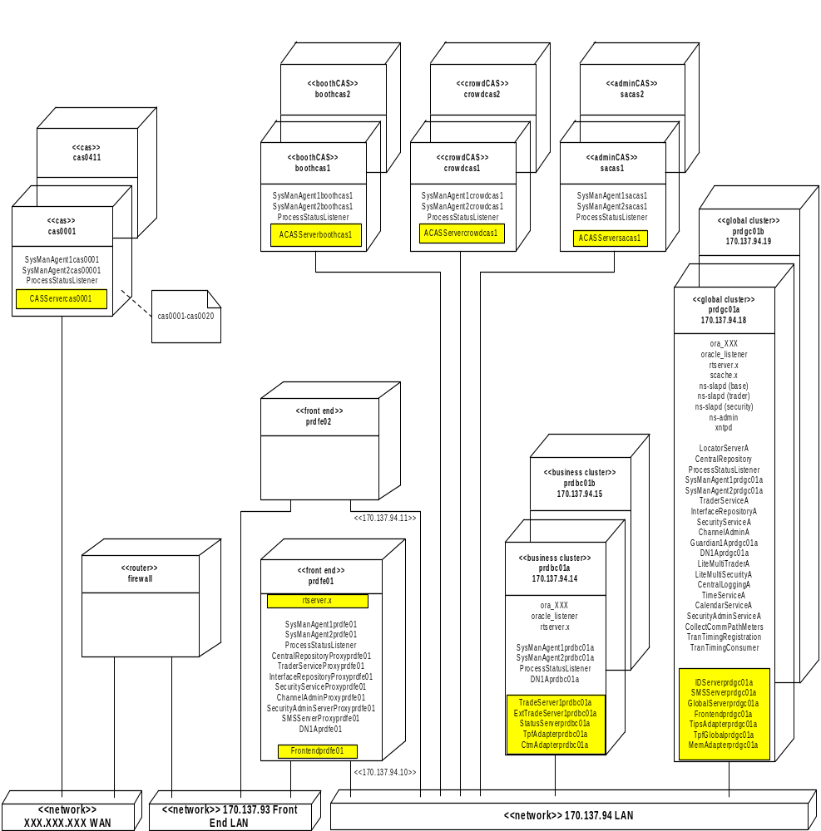

IdServer, GlobalServer, TradeServer, ExtTradeServer, StatusServer, TipsAdapter, TpfAdapter, TpfGlobalAdapter, CtmAdapter, MembershipAdapter

These processes are all handled identically with respect to failover. Each process is replicated at least once and is run in a process pair style configuration. This means that one process is active, or Master, and the other processes are inactive, or Slave, waiting to takeover as the master process. Application state is stored in a shared database between the processes so that no mechanism is needed to actively keep the processes in synch.

When a process goes Master, it will export all of its services to the Trader so clients may find the currently active services. If the master process fails, requests to that process will fail and will be automatically redirected by the Locator to the first service, therefore process, that becomes Master which handles that type of request.

The switch to Master for these processes is a manual operation.

Frontend

The Frontend process is a stateless, replicated process. Since the process is stateless, control can be automatically transferred to a different Frontend when a failure occurs and no need for master/slave switching is needed or used. The Frontend process consists of two different sets of proxies. The business services routing proxies are completely stateless. The Order and Quote Status Supplier proxies are statefull and contain callback objects from the associated CAS instances. The normal failover process does not protect the OSS & QSS portions of the Frontend process. These processes are instead redundant. Any one CAS connects to two Frontend OSS & QSS processes during normal startup.

Client Application Server (CAS)

The CAS is a stateless data cache of the SBT business data and current user data. It is not replicated nor does it employ the master/slave paradigm. A CAS can be configured for a given set of users and will cache the configured user’s business information. The CAS is configured at installation to connect to two Frontend servers in a pair relationship. This provides a redundant Order & Quote Status Supplier connection to the CAS.

SMS Server

SMS is very similar to the other application processes in that it runs in a process pair style configuration however the SMS does not utilize the Trader for letting clients obtain its services. SMS utilizes an IOR file which clients read. All other aspects of the failover for SMS are identical to that of the application.

Testing Application Failover

When an application component fails the system can be in one of two states upon receiving the next request.
- The process that is The “slave” process is still in slave state and therefore not ready to process.

- The “slave” process is already Master and is ready to process.

An assumption can be made that for 1 to work, 2 must work and therefore only 1 needs to be tested.

The following describes how to test scenario 1 for each application component. For each test that requires a process be killed, the test should be performed twice
- execute: kill <pid>
- execute: kill –9 <pid>

IdServer

- Login to primary and backup business server using tradeeng application login.
- Startup the application processes per standard procedure.
- Kill the Master IdServer.
  - To find the pid, execute chk on the machine on which the process is running
  - To kill the process execute kill [-9] <pid>
- Submit a new order
- Switch the Slave IdServer to Master per standard procedure.
- The new Master will process the command.
  - Check the Locator log to determine if the request was sent to the proper IdServer (see How to interpret the Locator log)
  - Verify the order was accepted

GlobalServer

- Login to primary and backup global server as tradeeng application login.
- Startup the application processes per standard procedure.
- Kill the Master GlobalServer.
  - To find the pid execute chk on the machine on which the process is running
For example,
pid 12160 atgtest1_AExtTradeServeratgsvr1
pid 11788 atgtest1_AGlobalServeratgsvr1
pid 11664 atgtest1_AIdServeratgsvr1
pid 11960 atgtest1_ASMSServeratgsvr1
pid 12209 atgtest1_AStatusServeratgsvr1
pid 11995 atgtest1_AtradeServeratgsvr1
  - Kill the process: kill [-9] <pid>
- Send a request to display all trading sessions.
  - tssClient getAllSessions
- Switch the Slave GlobalServer to Master per standard procedure.
- The new Master will process the command.
  - Check the Locator log to determine if the request was sent to the proper GlobalServer (see How to interpret the Locator log)
  - The command should produce a list of TradingSessions. For example,
Session_0.sessionName = "W_MAIN2"
Session_0.sessionDestinationCode = 1
Session_0.sessionState = 1
Session_0.endOfSessionStrategy = "default"
Session_0.isLastSessionForBusinessDay = false
Session_0.autoStartEndOfSession = true
Session_0.abortEndOfSession = false
Session_0.endOfSessionEventCompleted = 0
Session_0.endOfSessionEventInProgress = 0

Session_0.businessDay.month = 10
Session_0.businessDay.day = 3

TradeServer

- Login to primary and backup business server using tradeeng application login.
- Startup the application processes per standard procedure.
- Kill the Master TradeServer.
  - To find the pid execute chk on the machine on which the process is running
  - To kill the process execute kill [-9] <pid>
- Submit a test order
- Switch the Slave TradeServer to Master per standard procedure.
- The new Master will process the command.
  - Check the Locator log to determine if the request was sent to the proper TradeServer (see How to interpret the Locator log)
  - Verify the order was accepted

ExtTradeServer

- Login to primary and backup business server using tradeeng application login.
- Startup the application processes per standard procedure.
- Kill the Master ExtTradeServer.
  - To find the pid execute chk on the machine on which the process is running
  - To kill the process execute kill [-9] <pid>
- Submit a test order
- Switch the Slave ExtTradeServer to Master per standard procedure.
- The new Master will process the command.
  - Check the Locator log to determine if the request was sent to the proper ExtTradeServer (see How to interpret the Locator log)
  - Verify the order was accepted BY TPF.

Status Server

- Login to primary and backup business server using tradeeng application login.
- Startup the application processes per standard procedure.
- Kill the Master StatusServer.
- To find the pid execute chk on the machine on which the process is running
- To kill the process execute kill [-9] <pid>
- Submit a test order using a trader qui.
- Switch the Slave StatusServer to Master per standard procedure.
- The new Master will process the command.
- Verify the Trader gui shows the Order statuses that the test order was accepted.

Membership Adapter
- Login to primary and backup global server using tradeeng application login.
- Startup the application processes per standard procedure.
- Kill the Master MemAdapter.
- To find the pid execute chk on the machine on which the process is running
- To kill the process execute kill [-9] <pid>
- Switch the Slave MemAdapter to Master per standard procedure.
- The new Master will start loading membership data.
- Verify the MemAdapter.log by executing “tail –f log/MemAdapter.log”. You will see messages indicating that the MemAdapter is loading firms etc… (See the operation’s Guide For More details on log messages).

TipsAdapter & TpfGlobalAdapter (Global Server)
- Login to primary and backup global server using tradeeng application login.
- Startup the application processes per standard procedure.
- You can either kill the Master TipsAdapter and TpfGlobalAdapter or you can put them in the slave state.
- To find the pid execute chk on the machine on which the process is running
- To kill the process execute kill [-9] <pid>

- If you killed the processes then you can skip the next step.
- We will check to make sure all the global connections are down before switching over to the new master processes.
6.1 cd $RUN_DIR on the primary global server.
6.2 Type the command globalExternalServices check this will show a list of connections for both the TIPS and TPF Global. All the connections should be down. Here is a sample
Connection status for server TipsAdapter

TipsUnderlyingUdpAConnection No Connection
TipsUnderlyingUdpBConnection No Connection
TipsBestOfTheRestConnection No Connection
TipsUnderlyingConnection No Connection
TipsProductDownloadConnection No Connection

Sequencer status for server TpfGlobal (connected/loggedIn) (send#/recv#)
ControlService false/false
VsdlService false/false

- Switch the Slave Tips And TpfGlobal to Master per standard procedure.
- cd $RUN_DIR on the primary global server.
- Type the command globalExternalServices start A OR globalExternalServices start B (based on whether you want TIPS udp connection to connect to the Global A or global B backbone)
- Type the command globalExternalServices check. All the connections should be up (Exception: Only one Tips UDP connection will be up). Here is a sample
Connection status for server TipsAdapter

TipsUnderlyingUdpAConnection No Connection
TipsUnderlyingUdpBConnection Connected to 170.137.237.255:15001
TipsBestOfTheRestConnection Connected to m31a:30212
TipsUnderlyingConnection Connected to m31a:30212
TipsProductDownloadConnection Connected to m31a:30212

Sequencer status for server TpfGlobal (connected/loggedIn) (send#/recv#)
ControlService true/true
VsdlService true/true

TpfAdapter & CtmAdapter (Business Server)
- Login to primary and backup business server using tradeeng application login.
- Startup the application processes per standard procedure.
- You can either kill the Master TpfAdapter and CtmAdapter or you can put them in the slave state.
- To find the pid execute chk on the machine on which the process is running
- To kill the process execute kill [-9] <pid>

- If you killed the processes then you can skip the next step.
We will check to make sure all the global connections are down before switching over to the new master processes.
6.1 cd $RUN_DIR on the primary global server.
6.2 Type the command businessExternalServices check this will show a list of connections for both the TPF and CTM. All the connections should be down. Here is a sample
NOTE: Note down the sequence number for a couple of service’s (for TPF and CTM both), they will be used in the next step when you switch the new master processes for verification.
Sequencer status for server TpfAdapter (connected/loggedIn) (send#/recv#)
MdrService false/false
OrderServiceInbound false/false 0/0
ReportsServiceOutbound false/false 0/0
LastSaleService false/false 0/0
TagService false/false
OrderServiceOutbound false/false 0/0
ReportsServiceInbound false/false 0/0
QuoteService false/false 0/0

Sequencer status for server CtmAdapter (connected/loggedIn) (send#/recv#)

ReportsService false/false 0/0
AcknowledgementService false/false

- Switch the Slave TPF and CTM adapters to Master per standard procedure.
- cd $RUN_DIR on the primary global server.
- Type the command businessexternalServices start
- Type the command businessExternalServices check. All the connections should be up (Here is a sample
- Also make sure the sequence number’s for the couple of services you noted are still the same after the new processes have become master.
Sequencer status for server TpfAdapter (connected/loggedIn) (send#/recv#)
MdrService true/true
OrderServiceInbound true/true 0/0
ReportsServiceOutbound true/true 0/0
LastSaleService true/true 0/0
TagService true/true
OrderServiceOutbound true/true 0/0
ReportsServiceInbound true/true 0/0
QuoteService true/true 0/0

Sequencer status for server CtmAdapter (connected/loggedIn) (send#/recv#)

ReportsService true/true 0/0
AcknowledgementService true/true

SMSServer

- Login to primary and backup global server using tradeeng application login.
- Start the application processes per standard procedure.
- Connect a user (e.g. STL) from the Trader GUI via the CAS, as per standard procedure.
- Kill the Master SMSServer.
  - To find the pid execute chk on the machine on which the process is running
  - To kill the process execute kill [-9] <pid>
- Switch the Slave SMSServer to Master per standard procedure.
- Check that the user is still logged in.
  - From the machine that has the SMSServer running execute
ar SMSServer printUsers

User id ..: STL logged in ..: true session key ..: 53 source(s) ..: AdminCASServer
User id ..: CCC logged in ..: true session key ..: 13 source(s) ..: AdminCASServerC
User id ..: ACH logged in ..: false session key ..: 49 source(s) ..: null
User id ..: OCH logged in ..: false session key ..: 47 source(s) ..: null
User id ..: DDD logged in ..: false session key ..: 46 source(s) ..: null
User id ..: ACC logged in ..: false session key ..: 45 source(s) ..: null

  - Verify the user is still registered as logged in.

Frontend

- Start the application processes per standard procedure.
- Start a CAS per standard procedure.
- Kill the primary Frontend.
  - To find the pid run chk on the machine on which the Frontend process is running
  - To kill the process execute kill [-9] <pid>
- Submit a test order
- The new Master will process the command.
  - Check the Locator log to determine if the request was sent to the proper TradeServer (see How to interpret the Locator log)
  - Verify the order was accepted

Oracle Failover Tests
The highlighted processes in the diagram below are affected by Oracle failover tests.

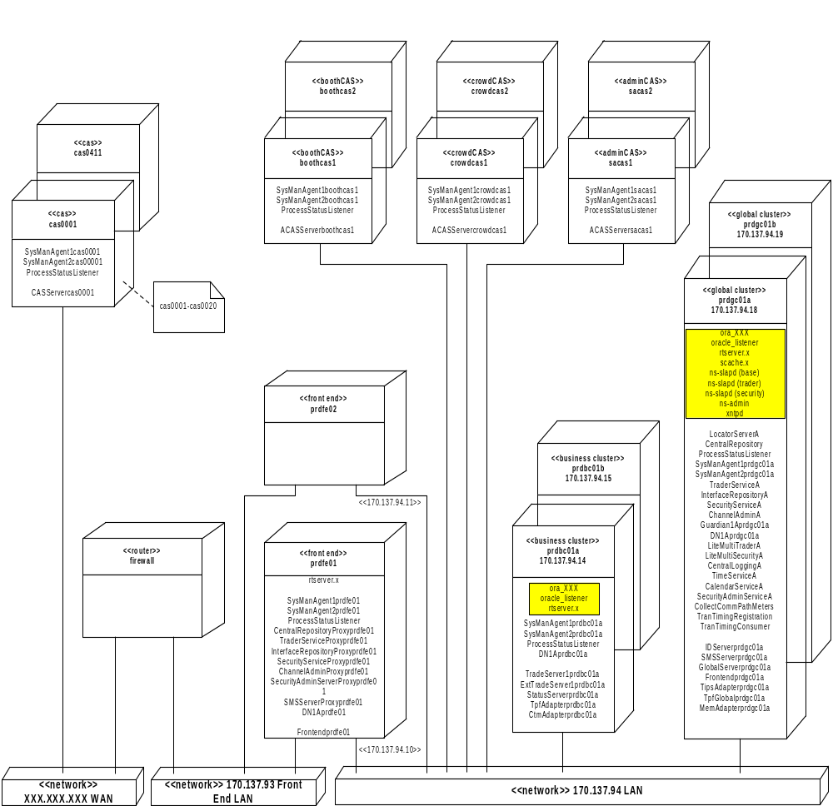

Interface Repository, Locator, Central Repository, Central Logging Server are the infrastructure processes connected to Oracle. Interface Repository and Locator communicate with Oracle through straight JDBC and the others go through JGrinder.

Interface Repository and Locator

Mechanism:
The process catches an SQLException when an Oracle Instance goes down or anything similar and it is passed through an SQLExceptionHelper to get a ranking for the exception. If it is a fatal exception, which in this case would be, the process is shutdown indicating the problem and the client receives a COMM_FAILURE and the failover is done as described in Scenario #3. The IFR and Locator will be shut down and the request is routed to the Secondary Locator which completes the Locate Request for the client.

How to test and Utility Used:

Kill the Oracle Instance on the A side of the Global Cluster and run the
command : repReader.sh –scope events

What to Look For:

Primary Locator and Interface Repository are killed on the A side and the Secondary Locator’s log
shows the Locate Request for the repReader.sh Utility and then the sequence of steps described in the section “Explanation of Locator log” can be observed in the Secondary Locator log.

Central Repository and Central Logging Server

A SQLException is caught by JGrinder and re-thrown as a QueryException when an Oracle Instance goes down or anything similar and it is passed through an SQLExceptionHelper to get a ranking for the exception. If it is a fatal exception, which in this case would be, the process is shutdown indicating the problem and the client receives a COMM_FAILURE and the failover is done as described in Scenario #3.

Publish-Subscribe Failover Mechanism
All the Publish-Subscribe tests are based a unit test framework used for testing the Distribution Nodes, Guardian, SmartCache and GMD Failover. These tests require their own Channel Admin Server running
before any of the tests described below can be run. Start the Failover Channel Admin as shown below :

prdgc01a /sbt/test/infra/run_dir $ cd $RUN_DIR ; startChannelAdminFailOver

RTserver Failover
Mechanism:
All the RTclients in the system point to a Talarian configuration file (default: ssconfig.cm) which has two RTservers listed in its server_names property (setopt server_names host1, host2). During the Event Flow, the RTserver (host1) is killed to which the RTclients are connected is killed. The consumer and the supplier re-establish the connection with the backup RTserver (host2) and the Event Flow resumes.

Testing Procedure:

- Start the Consumer and the Supplier
1.1 Starting the Consumer

prdgc01a /sbt/test/infra/run_dir/DistNodes/tests/GMDFailOver $ startGMDcons1;tc1
Starting Consumer ....
10671
Channel <DNBenchMulChannel> Narrowed Succesfully ....
TypedConsumerAdmin Created, id : 0
TypedProxyPushSupplier Created, id : 0
Connected to the Channel ...
Initialization Complete . Receiving Events
  - Starting the Supplier

prdgc01a /sbt/test/infra/run_dir/DistNodes/tests/GMDFailOver $ startGMDSupp;tsupp
Starting GMD Supplier ....
27901
Channel <DNBenchMulChannel> Found....
Channel <DNBenchMulChannel> narrows Successfully ....
TypedSupplierAdmin created . id : 0
Connected to the Channel ....
Start sending 100 Messages at 1 Messages/sec
Message Seq No. = 0
Message Seq No. = 1
Message Seq No. = 2
Message Seq No. = 3

  - Output on the Consumer after starting the supplier
Messages Seq No. = 0
Messages Seq No. = 1
Messages Seq No. = 2
Messages Seq No. = 3
Messages Seq No. = 4

- Kill the rtserver on the A side of the Global Cluster using rtserver –stop

prdgc01a /sbt/test/infra/run_dir/properties $ rtserver -stop
SmartSockets RTserver Version 5.2 Revision 3
Copyright 1991-1999 Talarian Corporation. All Rights Reserved.
For customer support in...
U.S. and Canada: support@talarian.com or (800) 883-8050
International: contact your local distributor
Connecting to project <rtworks> on <_node> RTserver.
Using local protocol.
Connecting to project <rtworks> on <_node> RTserver.
Using local protocol.
Message from RTserver: Connection established.
Start subscribing to subject </_prdgc01a_28162>.
Sending RTserver stop message.
Message from RTserver: RTserver stopping.
prdgc01a /sbt/test/infra/run_dir/properties $ RTserver exiting.

- The Message Flow should continue after the Supplier and Consumer reconnect to the backup rtserver.
The output for both the Consumer and Supplier is shown below:

  - Supplier

Message Seq No. = 18
Message Seq No. = 19
Message Seq No. = 20
Message Seq No. = 21
Connecting to project <CBOE> on <localhost> RTserver.
Using local protocol.
Could not connect to <localhost> RTserver.
Connecting to project <CBOE> on <localhost> RTserver.
Using tcp protocol.
Message from RTserver: Connection established.
Start subscribing to subject </ProdGMDSupplier>.
Message Seq No. = 22
Message Seq No. = 23
Message Seq No. = 24

3.2
Connecting to project <CBOE> on <localhost> RTserver.
Using local protocol.
Could not connect to <localhost> RTserver.
Connecting to project <CBOE> on <localhost> RTserver.
Using tcp protocol.
Message from RTserver: Connection established.
Start subscribing to subject </ProdGMDFailOverCons1>.
Messages Seq No. = 23
Messages Seq No. = 24

SmartCache Failover
Mechanism:
SmartCache is a Talarian process which acts like a GMD Store. It will be configured to listen on the GMD Channel Subjects. It stores the messages until the Supplier acks back to the rtserver and the rtserver in turn sends the message to the SmartCache to delete the message. When the primary SmartCache fails, the backup SmartCache detects it internally and takes over as a primary.

Testing Procedure:

- Start the Consumer and the Supplier
1.1 Starting the Consumer

prdgc01a /sbt/test/infra/run_dir/DistNodes/tests/GMDFailOver $ startGMDcons1;tc1
Starting Consumer ....
10671
Channel <DNBenchMulChannel> Narrowed Succesfully ....
TypedConsumerAdmin Created, id : 0
TypedProxyPushSupplier Created, id : 0
Connected to the Channel ...
Initialization Complete . Receiving Events

  - Starting the Supplier

prdgc01a /sbt/test/infra/run_dir/DistNodes/tests/GMDFailOver $ startGMDSupp;tsupp
Starting GMD Supplier ....
27901
Channel <DNBenchMulChannel> Found....
Channel <DNBenchMulChannel> narrows Successfully ....
TypedSupplierAdmin created . id : 0
Connected to the Channel ....
Start sending 100 Messages at 1 Messages/sec
Message Seq No. = 0
Message Seq No. = 1
Message Seq No. = 2
Message Seq No. = 3

  - Output on the Consumer Side after starting the Supplier
Messages Seq No. = 0
Messages Seq No. = 1
Messages Seq No. = 2
Messages Seq No. = 3
Messages Seq No. = 4

- Kill the SmartCache on the A side of the Global Cluster

2.1. To find the pid execute chk on the machine on which the process is running
For example,
SmartCache processes...

infra 21863 Mar_14 0:00
/opt/Talarian/ss52/bin/sun4_solaris/scache.x /sbt/test/infra/run_dir/properties/scachePrimaryMon.cm
infra 21858 Mar_14 1:03
/opt/Talarian/ss52/bin/sun4_solaris/scache.x/ sbt/test/infra/run_dir/properties/scachePrimary.cm

- Wait for a few seconds and restart the consumer. The consumer contacts the SmartCache on the B
side and fetches the GMD Messages. The Consumer receives all the GMD messages that were
published by the supplier . The first Message Seq No. based on 1.3 shown above should be 5.

prdgc01a /sbt/test/infra/run_dir/DistNodes/tests/GMDFailOver $ startGMDcons1;tc1
Starting Consumer ....
10671
Channel <DNBenchMulChannel> Narrowed Succesfully ....
TypedConsumerAdmin Created, id : 0
TypedProxyPushSupplier Created, id : 0
Connected to the Channel ...
Initialization Complete . Receiving Events.

Messages Seq No. = 5
Messages Seq No. = 6
Messages Seq No. = 7
Messages Seq No. = 8
Messages Seq No. = 9

GMD Failover
Mechanism:
When a consumer on a GMD Channel has crashed and is brought backup again, it receives all the GMD messages from the SmartCache. When the primary SmartCache goes down, it gets the messages from the Secondary SmartCache. The SmartCache needs to be configured to subscribe to the desired GMD Channels.

Testing Procedure:

- Start the Consumer and the Supplier
1.1 Starting the Consumer

prdgc01a /sbt/test/infra/run_dir/DistNodes/tests/GMDFailOver $ startGMDcons1;tc1
Starting Consumer ....
10671
Channel <DNBenchMulChannel> Narrowed Succesfully ....
TypedConsumerAdmin Created, id : 0
TypedProxyPushSupplier Created, id : 0
Connected to the Channel ...
Initialization Complete . Receiving Events

  - Starting the Supplier

prdgc01a /sbt/test/infra/run_dir/DistNodes/tests/GMDFailOver $ startGMDSupp;tsupp
Starting GMD Supplier ....
27901
Channel <DNBenchMulChannel> Found....
Channel <DNBenchMulChannel> narrows Successfully ....
TypedSupplierAdmin created . id : 0
Connected to the Channel ....
Start sending 100 Messages at 1 Messages/sec
Message Seq No. = 0
Message Seq No. = 1
Message Seq No. = 2
Message Seq No. = 3

  - Output on the Consumer Side after starting the supplier
Messages Seq No. = 0
Messages Seq No. = 1
Messages Seq No. = 2
Messages Seq No. = 3
Messages Seq No. = 4

- Kill the Consumer. After the kill note down the Last Message Seq No. displayed on the Screen.
2.1. To find the pid execute chk on the machine on which the process is running
For example,
pid 17937 ProdCalendarServiceA
pid 17583 ProdCentralLoggingA
pid 9620 ProdCentralRepository
pid 16408 ProdChannelAdminA
pid 18018 ProdCollectCommPathMeters
pid 16906 ProdDNA
pid 1762 ProdDNFailOverChannelAdminA
pid 8922 ProdGMDFailOverCons1
pid 8980 ProdGMDSupplier
pid 15761 ProdInterfaceRepositoryA
pid 17423 ProdLiteMultiSecurityA
pid 17240 ProdLiteMultiTraderA
pid 12580 ProdLocatorServerA
pid 13400 ProdProcessStatusListener
pid 17979 ProdSecurityAdminServiceA
pid 15899 ProdSecurityServiceA
pid 13412 ProdSysManAgent1prdgc01a
pid 15695 ProdSysManAgent2prdgc01a
pid 17666 ProdTimeServiceA
pid 15718 ProdTraderServiceA
pid 18220 ProdTranTimingConsumer
pid 18116 ProdTranTimingRegistration

2.2. Kill the Process: kill [-9] <pid> Ex. In this case, kill 8922

- Restart the Consumer. After restarting, the consumer should get all the messages after it was killed.
i.e., the first Message Seq No. based on 1.3 shown above should be 5.
prdgc01a /sbt/test/infra/run_dir/DistNodes/tests/GMDFailOver $ startGMDcons1;tc1
Starting Consumer ....
10671
Channel <DNBenchMulChannel> Narrowed Succesfully ....
TypedConsumerAdmin Created, id : 0
TypedProxyPushSupplier Created, id : 0
Connected to the Channel ...
Initialization Complete . Receiving Events.

Messages Seq No. = 5
Messages Seq No. = 6
Messages Seq No. = 7
Messages Seq No. = 8
Messages Seq No. = 9

Distribution Node Failover and Filter Recovery
Mechanism:
Communication between DN's is global and communication between a DN and a DNACS is local. Every DN has a backup DN, which is brought up with the property server_msg_send, set to false. The backup DN would essentially be in a discarding mode in which it receives all the events, which the primary does but does forward any of those messages. When the Primary DN is killed while there is event flow through the DN, the guardian detects that the DN went down and sends a switch signal to the backup DN to take over. Once the switch signal is sent, switch takes place and the event flow resumes. In the process of switching, the listener thread pool is shutdown, then the property server_msg_send is set to true, listener thread pool is initialized, filters are played back, and resubscribe on all the subjects takes place.
A Native Executable DNSwitchClient can also be used to manually switch the backup DN to Primary mode.

Testing Procedure:

- Start the Distribution Nodes, Consumer and the Supplier in the Following Order
  - Starting the Distribution Nodes
    - Starting the Global Cluster Primary Distribution Node
prdgc01a /sbt/test/infra/run_dir/ $
startDNPrimary GlobalClusterOnePrimary 1;tailDNGCPrim

<SYS-NOTIFY> < Sat 2001/03/17 11:41:55:50 > FilterNode: AddIncludeAllConstraints for
IDL:omg.org/CosTypedEventComm/TypedPushConsumer:1.0
<SYS-NOTIFY> < Sat 2001/03/17 11:41:55:50 > FilterNode: AddIncludeAllConstraints for
IDL:omg.org/CosTypedEventComm/TypedPushConsumer:1.0
<SYS-NOTIFY> < Sat 2001/03/17 11:41:55:50 > FilterNode: AddIncludeAllConstraints for
IDL:omg.org/CosTypedEventComm/TypedPushConsumer:1.0
<SYS-NOTIFY> < Sat 2001/03/17 11:41:55:50 > FilterNode: AddIncludeAllConstraints for
IDL:omg.org/CosTypedEventComm/TypedPushConsumer:1.0
<SYS-NOTIFY> < Sat 2001/03/17 11:41:55:50 > FilterNode: AddIncludeAllConstraints for
IDL:omg.org/CosTypedEventComm/TypedPushConsumer:1.0
<SYS-NOTIFY> < Sat 2001/03/17 11:41:55:52 > Setting up the Signal Handlers to handle HUP and INT
Signals.
<SYS-NOTIFY> < Sat 2001/03/17 11:41:55:53 > FilterNodeApp: DN Initialization Complete

1.1.2 Starting the Global Cluster Secondary Distribution Node
prdgc01a /sbt/test/infra/run_dir/ $
startDNSecondary GlobalClusterOnePrimary 1 ; tailDNGCSec

<SYS-NOTIFY> < Sat 2001/03/17 11:41:55:50 > FilterNode: AddIncludeAllConstraints for
IDL:omg.org/CosTypedEventComm/TypedPushConsumer:1.0
<SYS-NOTIFY> < Sat 2001/03/17 11:41:55:50 > FilterNode: AddIncludeAllConstraints for
IDL:omg.org/CosTypedEventComm/TypedPushConsumer:1.0
<SYS-NOTIFY> < Sat 2001/03/17 11:41:55:50 > FilterNode: AddIncludeAllConstraints for
IDL:omg.org/CosTypedEventComm/TypedPushConsumer:1.0
<SYS-NOTIFY> < Sat 2001/03/17 11:41:55:50 > FilterNode: AddIncludeAllConstraints for
IDL:omg.org/CosTypedEventComm/TypedPushConsumer:1.0
<SYS-NOTIFY> < Sat 2001/03/17 11:41:55:50 > FilterNode: AddIncludeAllConstraints for
IDL:omg.org/CosTypedEventComm/TypedPushConsumer:1.0
<SYS-NOTIFY> < Sat 2001/03/17 11:41:55:52 > Setting up the Signal Handlers to handle HUP and INT
Signals.
<SYS-NOTIFY> < Sat 2001/03/17 11:41:55:53 > FilterNodeApp: DN Initialization Complete

1.1.3 Starting the Front End Primary Distribution Node
prdgc01a /sbt/test/infra/run_dir/ $
startDNPrimary FrontEndDN 2; tailDNFEPrim

<SYS-NOTIFY> < Sat 2001/03/17 11:41:55:50 > FilterNode: AddIncludeAllConstraints for
IDL:omg.org/CosTypedEventComm/TypedPushConsumer:1.0
<SYS-NOTIFY> < Sat 2001/03/17 11:41:55:50 > FilterNode: AddIncludeAllConstraints for
IDL:omg.org/CosTypedEventComm/TypedPushConsumer:1.0
<SYS-NOTIFY> < Sat 2001/03/17 11:41:55:50 > FilterNode: AddIncludeAllConstraints for
IDL:omg.org/CosTypedEventComm/TypedPushConsumer:1.0
<SYS-NOTIFY> < Sat 2001/03/17 11:41:55:50 > FilterNode: AddIncludeAllConstraints for
IDL:omg.org/CosTypedEventComm/TypedPushConsumer:1.0
<SYS-NOTIFY> < Sat 2001/03/17 11:41:55:50 > FilterNode: AddIncludeAllConstraints for
IDL:omg.org/CosTypedEventComm/TypedPushConsumer:1.0
<SYS-NOTIFY> < Sat 2001/03/17 11:41:55:52 > Setting up the Signal Handlers to handle HUP and INT
Signals.
<SYS-NOTIFY> < Sat 2001/03/17 11:41:55:53 > FilterNodeApp: DN Initialization Complete

  - Starting the Consumer
prdgc01a /sbt/test/infra/run_dir/$ startDNCons1;tcdn1
Starting Consumer ....
7529
Channel <DNBenchMulChannel> Narrowed Succesfully ....
TypedConsumerAdmin Created, id : 0
TypedProxyPushSupplier Created, id : 0
Connected to the Channel ...
Initialization Complete . Receiving Events

  - Starting the Supplier
prdgc01a /sbt/test/infra/run_dir/DistNodes/tests/GMDFailOver $ startGMDSupp;tsupp
Starting GMD Supplier ....
27901
Channel <DNBenchMulChannel> Found....
Channel <DNBenchMulChannel> narrows Successfully ....
TypedSupplierAdmin created . id : 0
Connected to the Channel ....
Start sending 100 Messages at 1 Messages/sec
Message Seq No. = 0
Message Seq No. = 1
Message Seq No. = 2
Message Seq No. = 3

  - Output at the Consumer after starting the Supplier
Messages Seq No. = 0
Messages Seq No. = 1
Messages Seq No. = 2
Messages Seq No. = 3
Messages Seq No. = 4

- Kill the Primary Distribution Node on the Global Cluster
2.1 To find the pid execute chk on the machine on which the process is running
For example,
details for java processes on host prdgc01a for ID infra, environment <Prod>
pid 17937 ProdCalendarServiceA
pid 17583 ProdCentralLoggingA
pid 9620 ProdCentralRepository
pid 16408 ProdChannelAdminA
pid 18018 ProdCollectCommPathMeters
pid 16906 ProdDNA
pid 1762 ProdDNFailOverChannelAdminA
pid 7529 ProdDNFailOverCons1
pid 2226 ProdDNFailOverDN1AGlobalClusterOnePrimary
pid 2872 ProdDNFailOverDN1BGlobalClusterOnePrimary
pid 2987 ProdDNFailOverDN2AFrontEndDN
pid 15761 ProdInterfaceRepositoryA
pid 17423 ProdLiteMultiSecurityA
pid 17240 ProdLiteMultiTraderA
pid 12580 ProdLocatorServerA
pid 13400 ProdProcessStatusListener
pid 17979 ProdSecurityAdminServiceA
pid 15899 ProdSecurityServiceA
pid 13412 ProdSysManAgent1prdgc01a
pid 15695 ProdSysManAgent2prdgc01a
pid 17666 ProdTimeServiceA
pid 15718 ProdTraderServiceA
pid 18220 ProdTranTimingConsumer
pid 18116 ProdTranTimingRegistration

2.2. Kill the Process: kill [-9] <pid> Ex. In this case, kill 2226

- Output at the Secondary DN started in the step 1.1.2

<SYS-NOTIFY> < Sat 2001/03/17 12:19:07:76 > FilterNodeApp: reSubscribing to subject DNBenchMulChannel/IDL:omg.org/CosEventComm/PushConsumer:1.0---DNBenchMulChannelLocalBC1---local
<SYS-NOTIFY> < Sat 2001/03/17 12:19:07:76 > FilterNodeApp: reSubscribing to subject AdminChannel/IDL:NotificationService/NodeFilterAdmin:1.0---DNBenchMulChannel---DNBenchMulChannelDNGlobalCluster1---global
<SYS-NOTIFY> < Sat 2001/03/17 12:19:07:76 > FilterNodeApp: reSubscribing to subject DNBenchMulChannel/IDL:DistNodeBench/QuotesDnBench:1.0---DNBenchMulChannelLocalBC1---local
<SYS-NOTIFY> < Sat 2001/03/17 12:19:07:76 > FilterNodeApp: reSubscribing to subject DNBenchMulChannel/IDL:omg.org/CosTypedEventComm/TypedPushConsumer:1.0---DNBenchMulChannelLocalBC1---local
<SYS-NOTIFY> < Sat 2001/03/17 12:19:07:76 > FilterNodeApp: reSubscribing to subject AdminChannel/IDL:NodeInterfaceAdmin:1.0---DNBenchMulChannel---DNBenchMulChannelDNGlobalCluster1---global
<SYS-NOTIFY> < Sat 2001/03/17 12:19:07:77 > FilterNodeApp: reSubscribing to subject AdminChannel
<SYS-NOTIFY> < Sat 2001/03/17 12:19:07:77 > Updating the Distribution Node State to <ACTIVE> State
<SYS-ALARM> < Sat 2001/03/17 12:19:07:77 > DistributionNode: DN Switch has occurred.Primary DN ProdDNFailOverDN1AGlobalClusterOnePrimaryhas failed.Secondary DN taking Over

- Output at the Consumer after the Secondary DN takes Over.
The Consumer starts receiving the messages after the switch is done.
Messages Seq No. = 7
Messages Seq No. = 8
Messages Seq No. = 9
Messages Seq No. = 10
Messages Seq No. = 11
Messages Seq No. = 12
Messages Seq No. = 13
Messages Seq No. = 14
Messages Seq No. = 16
Messages Seq No. = 17

Guardian Failover
Mechanism:

Guardians are configured such that each watches other's failure. When one of them is killed, the other gets notified and if the crashed guardian was primary, the secondary gets notified and takes over as a primary. When the secondary goes down, a message is logged indicating its failure.

Testing Procedure:

Make sure the Primary and Secondary Guardian Processes are up and running, This is part of the Standard
Procedure.

- Start the Distribution Nodes, Consumer and the Supplier in the Following Order
  - Starting the Distribution Nodes
    - Starting the Global Cluster Primary Distribution Node
prdgc01a /sbt/test/infra/run_dir/ $
startDNPrimary GlobalClusterOnePrimary 1;tailDNGCPrim

<SYS-NOTIFY> < Sat 2001/03/17 11:41:55:50 > FilterNode: AddIncludeAllConstraints for
IDL:omg.org/CosTypedEventComm/TypedPushConsumer:1.0
<SYS-NOTIFY> < Sat 2001/03/17 11:41:55:50 > FilterNode: AddIncludeAllConstraints for
IDL:omg.org/CosTypedEventComm/TypedPushConsumer:1.0
<SYS-NOTIFY> < Sat 2001/03/17 11:41:55:50 > FilterNode: AddIncludeAllConstraints for
IDL:omg.org/CosTypedEventComm/TypedPushConsumer:1.0
<SYS-NOTIFY> < Sat 2001/03/17 11:41:55:50 > FilterNode: AddIncludeAllConstraints for
IDL:omg.org/CosTypedEventComm/TypedPushConsumer:1.0
<SYS-NOTIFY> < Sat 2001/03/17 11:41:55:50 > FilterNode: AddIncludeAllConstraints for
IDL:omg.org/CosTypedEventComm/TypedPushConsumer:1.0
<SYS-NOTIFY> < Sat 2001/03/17 11:41:55:52 > Setting up the Signal Handlers to handle HUP and INT
Signals.
<SYS-NOTIFY> < Sat 2001/03/17 11:41:55:53 > FilterNodeApp: DN Initialization Complete

1.1.2 Starting the Global Cluster Secondary Distribution Node
prdgc01a /sbt/test/infra/run_dir/ $
startDNSecondary GlobalClusterOnePrimary 1 ; tailDNGCSec

<SYS-NOTIFY> < Sat 2001/03/17 11:41:55:50 > FilterNode: AddIncludeAllConstraints for
IDL:omg.org/CosTypedEventComm/TypedPushConsumer:1.0
<SYS-NOTIFY> < Sat 2001/03/17 11:41:55:50 > FilterNode: AddIncludeAllConstraints for
IDL:omg.org/CosTypedEventComm/TypedPushConsumer:1.0
<SYS-NOTIFY> < Sat 2001/03/17 11:41:55:50 > FilterNode: AddIncludeAllConstraints for
IDL:omg.org/CosTypedEventComm/TypedPushConsumer:1.0
<SYS-NOTIFY> < Sat 2001/03/17 11:41:55:50 > FilterNode: AddIncludeAllConstraints for
IDL:omg.org/CosTypedEventComm/TypedPushConsumer:1.0
<SYS-NOTIFY> < Sat 2001/03/17 11:41:55:50 > FilterNode: AddIncludeAllConstraints for
IDL:omg.org/CosTypedEventComm/TypedPushConsumer:1.0
<SYS-NOTIFY> < Sat 2001/03/17 11:41:55:52 > Setting up the Signal Handlers to handle HUP and INT
Signals.
<SYS-NOTIFY> < Sat 2001/03/17 11:41:55:53 > FilterNodeApp: DN Initialization Complete

1.1.3 Starting the Front End Primary Distribution Node
prdgc01a /sbt/test/infra/run_dir/ $
startDNPrimary FrontEndDN 2; tailDNFEPrim

<SYS-NOTIFY> < Sat 2001/03/17 11:41:55:50 > FilterNode: AddIncludeAllConstraints for
IDL:omg.org/CosTypedEventComm/TypedPushConsumer:1.0
<SYS-NOTIFY> < Sat 2001/03/17 11:41:55:50 > FilterNode: AddIncludeAllConstraints for
IDL:omg.org/CosTypedEventComm/TypedPushConsumer:1.0
<SYS-NOTIFY> < Sat 2001/03/17 11:41:55:50 > FilterNode: AddIncludeAllConstraints for
IDL:omg.org/CosTypedEventComm/TypedPushConsumer:1.0
<SYS-NOTIFY> < Sat 2001/03/17 11:41:55:50 > FilterNode: AddIncludeAllConstraints for
IDL:omg.org/CosTypedEventComm/TypedPushConsumer:1.0
<SYS-NOTIFY> < Sat 2001/03/17 11:41:55:50 > FilterNode: AddIncludeAllConstraints for
IDL:omg.org/CosTypedEventComm/TypedPushConsumer:1.0
<SYS-NOTIFY> < Sat 2001/03/17 11:41:55:52 > Setting up the Signal Handlers to handle HUP and INT
Signals.
<SYS-NOTIFY> < Sat 2001/03/17 11:41:55:53 > FilterNodeApp: DN Initialization Complete

  - Starting the Consumer
prdgc01a /sbt/test/infra/run_dir/$ startDNCons1;tcdn1
Starting Consumer ....
7529
Channel <DNBenchMulChannel> Narrowed Succesfully ....
TypedConsumerAdmin Created, id : 0
TypedProxyPushSupplier Created, id : 0
Connected to the Channel ...
Initialization Complete . Receiving Events

  - Starting the Supplier
prdgc01a /sbt/test/infra/run_dir/DistNodes/tests/GMDFailOver $ startGMDSupp;tsupp
Starting GMD Supplier ....
27901
Channel <DNBenchMulChannel> Found....
Channel <DNBenchMulChannel> narrows Successfully ....
TypedSupplierAdmin created . id : 0
Connected to the Channel ....
Start sending 100 Messages at 1 Messages/sec
Message Seq No. = 0
Message Seq No. = 1
Message Seq No. = 2
Message Seq No. = 3

  - Output at the Consumer after starting the Supplier
Messages Seq No. = 0
Messages Seq No. = 1
Messages Seq No. = 2
Messages Seq No. = 3
Messages Seq No. = 4

- Kill the Primary Guardian on the A Side of the Global Cluster
2.1 To find the pid execute chk on the machine on which the process is running
For example,

LDAP, Talarian, Guardian processes...

infra 28319 1 0 Feb 21 ? 1:15 ./ns-slapd -f /usr/netscape/server4/slapd-Base/config/slapd.conf -i /
usr/netsca
infra 26695 1 0 Mar 11 ? 0:52 ./ns-slapd -f /usr/netscape/server4/slapd-SecurityService/config/slap
d.conf -i
infra 7573 1 0 Mar 09 ? 8:04 ./ns-slapd -f /usr/netscape/server4/slapd-TraderService/config/slapd.
conf -i /u
infra 7655 1 0 Feb 21 ? 0:03 ./ns-admin -d /usr/netscape/server4/admin-serv/config
infra 1999 1 0 12:01:17 pts/16 0:04 Guardian_d -DORB.OrbName=ProdGuardian1Aprdgc01a -DORB.PortNum=21558 -DORB.Ini
2.2 Kill the Process: kill [-9] <pid> Ex. In this case, kill 1999

- Kill the Primary Distribution Node on the Global Cluster
3.1 To find the pid execute chk on the machine on which the process is running
For example,
details for java processes on host prdgc01a for ID infra, environment <Prod>
pid 17937 ProdCalendarServiceA
pid 17583 ProdCentralLoggingA
pid 9620 ProdCentralRepository
pid 16408 ProdChannelAdminA
pid 18018 ProdCollectCommPathMeters
pid 16906 ProdDNA
pid 1762 ProdDNFailOverChannelAdminA
pid 7529 ProdDNFailOverCons1
pid 2226 ProdDNFailOverDN1AGlobalClusterOnePrimary
pid 2872 ProdDNFailOverDN1BGlobalClusterOnePrimary
pid 2987 ProdDNFailOverDN2AFrontEndDN
pid 15761 ProdInterfaceRepositoryA
pid 17423 ProdLiteMultiSecurityA
pid 17240 ProdLiteMultiTraderA
pid 12580 ProdLocatorServerA
pid 13400 ProdProcessStatusListener
pid 17979 ProdSecurityAdminServiceA
pid 15899 ProdSecurityServiceA
pid 13412 ProdSysManAgent1prdgc01a
pid 15695 ProdSysManAgent2prdgc01a
pid 17666 ProdTimeServiceA
pid 15718 ProdTraderServiceA
pid 18220 ProdTranTimingConsumer
pid 18116 ProdTranTimingRegistration

3.2. Kill the Process: kill [-9] <pid> Ex. In this case, kill 2226

- Output at the Secondary DN started in the step 1.1.2

<SYS-NOTIFY> < Sat 2001/03/17 12:19:07:76 > FilterNodeApp: reSubscribing to subject DNBenchMulChannel/IDL:omg.org/CosEventComm/PushConsumer:1.0---DNBenchMulChannelLocalBC1---local
<SYS-NOTIFY> < Sat 2001/03/17 12:19:07:76 > FilterNodeApp: reSubscribing to subject AdminChannel/IDL:NotificationService/NodeFilterAdmin:1.0---DNBenchMulChannel---DNBenchMulChannelDNGlobalCluster1---global
<SYS-NOTIFY> < Sat 2001/03/17 12:19:07:76 > FilterNodeApp: reSubscribing to subject DNBenchMulChannel/IDL:DistNodeBench/QuotesDnBench:1.0---DNBenchMulChannelLocalBC1---local
<SYS-NOTIFY> < Sat 2001/03/17 12:19:07:76 > FilterNodeApp: reSubscribing to subject DNBenchMulChannel/IDL:omg.org/CosTypedEventComm/TypedPushConsumer:1.0---DNBenchMulChannelLocalBC1---local
<SYS-NOTIFY> < Sat 2001/03/17 12:19:07:76 > FilterNodeApp: reSubscribing to subject AdminChannel/IDL:NodeInterfaceAdmin:1.0---DNBenchMulChannel---DNBenchMulChannelDNGlobalCluster1---global
<SYS-NOTIFY> < Sat 2001/03/17 12:19:07:77 > FilterNodeApp: reSubscribing to subject AdminChannel
<SYS-NOTIFY> < Sat 2001/03/17 12:19:07:77 > Updating the Distribution Node State to <ACTIVE> State
<SYS-ALARM> < Sat 2001/03/17 12:19:07:77 > DistributionNode: DN Switch has occurred.Primary DN ProdDNFailOverDN1AGlobalClusterOnePrimaryhas failed.Secondary DN taking Over

- Output at the Consumer after the Secondary Guardian taking over and sending a signal to the Secondary DN. The Consumer starts receiving the messages after the switch is done.
Messages Seq No. = 7
Messages Seq No. = 8
Messages Seq No. = 9
Messages Seq No. = 10
Messages Seq No. = 11
Messages Seq No. = 12
Messages Seq No. = 13
Messages Seq No. = 14
Messages Seq No. = 16
Messages Seq No. = 17

LDAP Failover Tests
Trader Service and Security Service use Netscape Directory Server (NDS) as their persistent data store. Two Instances of NDS run on each box of the global cluster, one for Trader Service and the other for Security Service. The standard ports, which the instances listen on, are 2389 for Trader LDAP Instance and 3389 for Security service LDAP Instance. Currently, Netscape does not provide multi-master replication of two NDS Instances. So, a combination of SIR (Supplier Initiated Replication) and custom-built LiteMulti process provides the needed multi-master replication between the Instances. When an LDAP Instance fails or a LiteMulti process fails, certain critical steps need to be followed for recovery.

Setup for multi-master replication:

LDAP Instance A
LDAP Instance A’
LiteMulti
LiteMulti
dc=machineA
dc=machineB
SIR
SIR → Supplier Initiated Replication
prdgc01a
prdgc01b

As shown in the above figure, the SIR keeps the main primary branches in sync and the LiteMulti process listens on the branch being updated and updates the other branch in the database. Checking theTtimeStamp stops the loop.

LDAP Instance Failure
When a query/update is made to the Trader Service or the Security Service and the instance it is connected to is gone, an exception is caught indicating the failure and the process is shutdown. This returns a COMM_FAILURE to the client and the request is then handled as in Scenario #3 (see page 3).
All the updates that are done to the backup LDAP are also queued and sent using SIR to the recovered LDAP. The LiteMulti process that listens on the branch updates the other branch.

Testing External Failures

Infrastructure Component Failures

All infrastructure components on which we depend should have the appearance of never failing since each of them provides transparent failover to a redundant process. For each component on which the application components rely, transparent failover needs to be validated. The components to be validated are

Trader
Locator
Interface Repository
SysManAgent

For each of these components validate that failing the component will result in a replicant version handling the request and the application sees no indication of the failure.

Trader

- Start the application processes per standard procedure.
- During startup of the GlobalServer perform the failure test for the Trader.
- Verify that the GlobalServer started successfully.
  - Search log/GlobalServer.log for the word ‘systemAlarm’, this should not be found.
  - Verify that the GlobalServer completed startup per standard procedure

Locator

- Begin the TradeServer test above.
- After step 10 and before step 11 perform the failure test for the Locator
- Complete the TradeServer test above.

InterfaceRespository (IFR)

- Start the application processes per standard procedure.
- During startup of the GlobalServer perform the failure test for the IFR.
- Verify that the GlobalServer started successfully.
  - Search log/GlobalServer.log for the word ‘systemAlarm’, this should not be found.
  - Verify that the GlobalServer completed startup per standard procedure

SysManAgent

- Start the application processes per standard procedure.
- During startup of the GlobalServer perform the failure test for the SysManAgent.
- Verify that the GlobalServer started successfully.
  - Search log/GlobalServer.log for the word ‘systemAlarm’, this should not be found.
  - Verify that the GlobalServer completed startup per standard procedure

Testing Oracle Failures

An Oracle failure must be detected by the application and cause that application component to shutdown. This means that an Oracle failure becomes an application component failure.
To test –

- Start the application processes per standard procedure.
- Kill the primary Oracle instance.
  - (explain how to kill Oracle)
- Submit a test order
- Verify the TradeServer process exited.
  - Run ‘chk’ on the machine the Master TradeServer was running and the TradeServer should not be listed
- Switch the Slave TradeServer to Master per standard procedure.
- The new Master will process the command.
  - Check the Locator log to determine if the request was sent to the proper TradeServer (see How to interpret the Locator log)
  - Verify the order was accepted

CDB Failover
This section describes a CDB server failure scenario pertaining to replication and restarting. The diagram below depicts the SBT interface to the backoffice.

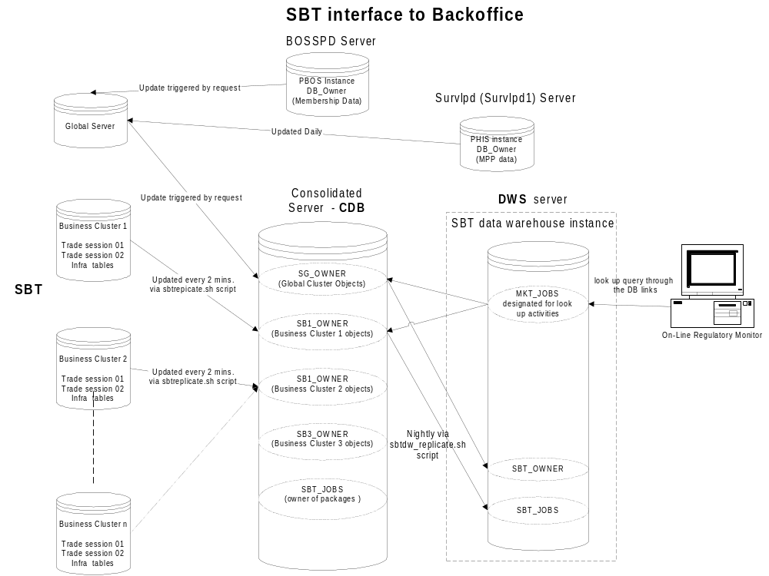

SBT Replication after Failover from prdcq01a to prdcq01b ( CDB )

- If Unix fails on prdcq01a ( the master of the prdca01ha cluster ), the sbtreplicate.sh script will cease running without having a chance to log messages anywhere.

- After prdcq01b gains control, the sbtresume.sh script should be called with the parameter of RECOVER: i.e. sbtresume.sh RECOVER. This will start up the sbtreplicate.sh script as well as log messages to the Oracle Monitor application and Patrol.

- The Oracle Monitor Application should be viewed after fail over. The monitor should contain the following messages if the sbtresume.sh script executed successfully:

*First message states that the sbtresume.sh script is attempting to begin replication

Applicaton: SBT_REPL

Type: Warning

Message Description: ATTEMPTING TO START REPLICATION AFTER FAILOVER

*Second message states that the sbtresume.sh script was successful in restarting replcation.

Applicaton: SBT_REPL

Type: Information

Message Description: REPLICATION STARTED SUCCESSFULLY AFTER FAILOVER

*Additional Messages can be viewed to verify that replication cycles are running normally:

Application: SBT_REPL

Type: Information

Message Description: SBT Replication script completed for this cycle

*Oracle Monitor screen capturing displaying replication restart messages after cdb fail over.
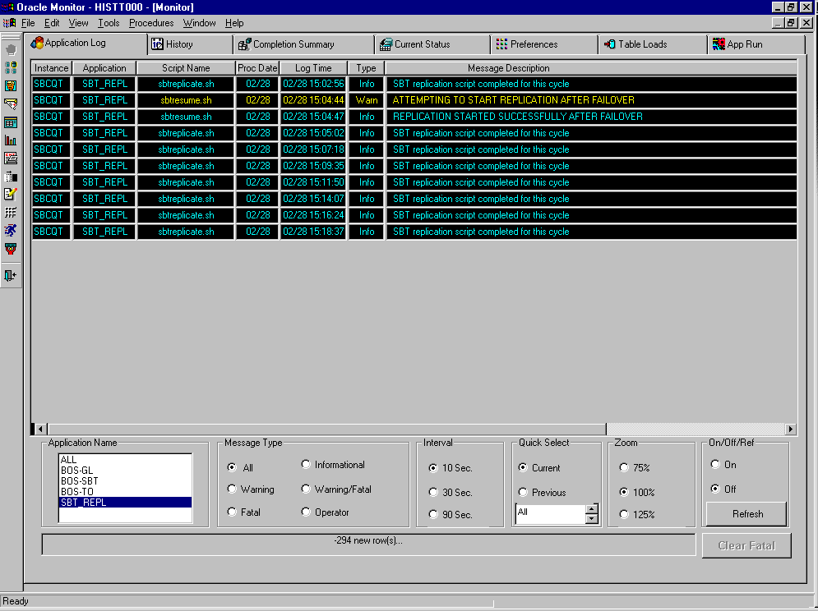
In addition to viewing the Oracle Monitor Application, the sbtresume.sh script creates a file written to the /localhome/sbtjobst/logfiles/resume.txt file. This file is in turn read by Patrol, and Patrol will display its contents. The message that Patrol will display is: Sbt replication started succesfully.

----Patrol Screen capture will be inserted here--------

CAS Failover

CAS Frontend Failure Testing
Repeat steps 1-8 for all listed Frontend components to test initial fail over. Additional test and secondary fail over steps indicated after steps 1-8.
- Server
- Channel Admin (proxy)
- Logging (proxy)
- Security Service (proxy)
- Trader Service (proxy)
- IFR (proxy)
- SMS (proxy)
- Central repository (proxy)
- Start the application processes per standard procedure.
- Start a CAS per standard procedure.
- Login a GUI Trader application. Please see GUI Trader Application Users Guide for further instructions on using the GUI Trader application.
- Kill the primary Frontend.
  - To find the pid run chk on the machine on which the Frontend process is running
  - To kill the process execute kill [-9] <pid>
- Submit a test order using the GUI Trader Application.
- The new Master will process the command.
  - Check the Locator log to determine if the request was sent to the proper TradeServer (see How to interpret the Locator log)
  - Verify the order was accepted. Trader application will receive a New and Booked status message and display it in the Market Data Window.
- Enter a quote to trade against the earlier order.
- Verify the Fill report is returned to the GUI Trader Application.
- Server
- Channel Admin (proxy)
- IFR (proxy)
- Security Service (proxy)
- Kill the secondary Frontend.
  - To find the pid run chk on the machine on which the secondary Frontend process is running
  - To kill the process execute kill [-9] <pid>
- Submit a test order or quote using the GUI Trader Application. This should cause an exception.
- Use the SMS console verify the user is no longer logged in.
  - From the machine that has the SMSServer running execute
ar SMSServer printUsers

User id ..: STL logged in ..: true session key ..: 53 source(s) ..: AdminCASServer
User id ..: CCC logged in ..: true session key ..: 13 source(s) ..: AdminCASServerC
User id ..: ACH logged in ..: false session key ..: 49 source(s) ..: null
User id ..: OCH logged in ..: false session key ..: 47 source(s) ..: null
User id ..: DDD logged in ..: false session key ..: 46 source(s) ..: null
User id ..: ACC logged in ..: false session key ..: 45 source(s) ..: null

  - Verify the user is still registered as logged out.
- Restart the Frontend machines.
- Using the Sysman console restart the CAS. Restarting the FE process will not allow the GUI to send orders or quotes. The CAS needs to be restarted and the users logged back in to reinitialize the OSS & QSS subsystems.
- Login a GUI Trader application.
- Submit a test order using the GUI Trader Application.
- Check the Locator log to determine if the request was sent to the proper TradeServer (see How to interpret the Locator log).
- Verify the order was accepted. Trader application will receive a New and Booked status message and display it in the Market Data Window.
- Trader Service (proxy)
- SMS (proxy)
- Log off from the trader GUI
- Shutdown the CAS from the Sysman console
- Restart the CAS
- Restart the trader GUI and log on
- Repeat order/quote entry from steps 6-8 to verify trading.
- Kill the secondary Frontend (follow step 9 above)
- Log off from the trader GUI. This should cause an exception.
- Shutdown the CAS from the command console. There should be exceptions in the CAS log.
- Any attempt to restart the CAS at this point should fail – exceptions in CAS log.
- Restart the Frontend machines.
- Using the Sysman console restart the CAS. Restarting the FE process will not allow the GUI to send orders or quotes. The CAS needs to be restarted and the users logged back in to reinitialize the OSS & QSS subsystems.
- Login a GUI Trader application.
- Submit a test order using the GUI Trader Application.
- Check the Locator log to determine if the request was sent to the proper TradeServer (see How to interpret the Locator log).
- Verify the order was accepted. Trader application will receive a New and Booked status message and display it in the Market Data Window.
- Logging (proxy)
- Log off from the trader GUI
- Shutdown the CAS from the Sysman console
- Restart the CAS
- Restart the trader GUI and log on
- Repeat order/quote entry from steps 6-8 to verify trading.
- Verify logging messages are being sent to the central repository (see How to view central log messages)
- Kill the secondary Frontend (follow step 9 above)
- Repeat the order/quote entry from steps 6-8. CAS log should indicate failure to central logging but CAS should continue to trade and log to CAS log file.
- Restart the Frontend machines.
- Using the Sysman console restart the CAS. Restarting the FE process will not allow the GUI to send orders or quotes. The CAS needs to be restarted and the users logged back in to reinitialize the OSS & QSS subsystems.
- Login a GUI Trader application.
- Submit a test order using the GUI Trader Application.
- Check the Locator log to determine if the request was sent to the proper TradeServer (see How to interpret the Locator log).
- Verify the order was accepted. Trader application will receive a New and Booked status message and display it in the Market Data Window.
- Central repository(proxy)

- Log off from the trader GUI
- Shutdown the CAS from the Sysman console
- Restart the CAS.
- Restart the Trader GUI and log on.
- Repeat order/quote entry from steps 6-8 to verify trading.
- Kill the secondary Frontend (follow step 9 above)
- Log off from the Trader GUI
- Shutdown the CAS using the Sysman console.
- Restart the CAS using the Sysman console.
- Restart the Trader GUI and log in.
- Repeat order/quote entry from steps 6-8 to verify trading.
- Kill the Agent process running on the CAS client (see kill instructions from step 9 above)
- Remove all the files from the localDB directory on the Agent client.
- Restart the Agent process ‘startSysManAgent’
- Restart the CAS from the Sysman console. The CAS should fail to start.
- Restart the Frontend machines.
- Restart the Agent on the CAS client machine.
- Using the Sysman console restart the CAS. Restarting the FE process will not allow the GUI to send orders or quotes. The CAS needs to be restarted and the users logged back in to reinitialize the OSS & QSS subsystems.
- Login a GUI Trader application.
- Submit a test order using the GUI Trader Application.
- Check the Locator log to determine if the request was sent to the proper TradeServer (see How to interpret the Locator log).
- Verify the order was accepted. Trader application will receive a New and Booked status message and display it in the Market Data Window.

CAS Infrastructure Failure Testing
Repeat the following steps for all listed Infrastructure components.
- RTServer
- Security Service

- Start the application processes per standard procedure.
- Start a CAS per standard procedure.
- Login a GUI Trader application. Please see GUI Trader Application Users Guide for further instructions on using the GUI Trader application.
- Fail the desired infrastructure component as per it’s detailed instructions.
- Submit a test order using the GUI Trader Application.
- Check the Locator log to determine if the request was sent to the proper TradeServer (see How to interpret the Locator log).
- Verify the order was accepted. The GUI Trader application will receive a New and Booked status message and display it in the Market Data Window.
- Enter a quote to trade against the earlier order.
- Verify the quote was accepted. The GUI Trader application will update the Market Data Window.
- Verify the Fill report is returned to the GUI Trader Application. The GUI Trader application will update the Market Data Window status pane and the Last Sale field will be updated.

CAS Server Failure Testing
Repeat the following steps for all listed Server components.
- Trade Server
- SMS

- Start the application processes per standard procedure.
- Start a CAS per standard procedure.
- Login a GUI Trader application. Please see GUI Trader Application Users Guide for further instructions on using the GUI Trader application.
- Fail the desired server component as per it’s detailed instructions.
- Submit a test order using the GUI Trader Application.
- Check the Locator log to determine if the request was sent to the proper TradeServer (see How to interpret the Locator log).
- Verify the order was accepted. The GUI Trader application will receive a New and Booked status message and display it in the Market Data Window.
- Enter a quote to trade against the earlier order.
- Verify the quote was accepted. The GUI Trader application will update the Market Data Window.
- Verify the Fill report is returned to the GUI Trader Application. The GUI Trader application will update the Market Data Window status pane and the Last Sale field will be updated.

ACAS Failover

ACAS Frontend Failure Testing
Repeat steps 1-8 for all listed Frontend components to test initial fail over. Additional test and secondary fail over steps indicated after steps 1-8.
- Server
- Channel Admin (proxy)
- Logging (proxy)
- Security Service (proxy)
- Trader Service (proxy)
- IFR (proxy)
- SMS (proxy)
- Central repository (proxy)
- Start the application processes per standard procedure.
- Start a ACAS per standard procedure.
- Login a Help Desk application. Please see Help Desk Application Users Guide for further instructions on using the Help Desk application.
- Start a CAS per standard procedure.
- Login a GUI Trader application. Please see GUI Trader Application Users Guide for further instructions on using the GUI Trader application.
- Kill the primary Frontend.
  - To find the pid run chk on the machine on which the Frontend process is running
  - To kill the process execute kill [-9] <pid>
- Submit a test order using the GUI Trader Application.
- Select the product you submitted an order for in the Book Depth Screen and display the order book depth using the Help Desk Application.
- The new Master will process the command.
  - Check the Locator log to determine if the request was sent to the proper TradeServer (see How to interpret the Locator log)
  - Verify the order was accepted. Trader application will receive a New and Booked status message and display it in the Market Data Window.
- Select a product in the Product Maintenance Screen and change it’s state.
- Verify the Product state change is reflected in on the GUI Trader Application Market Data Window.
- In the Help Desk Application, select the User Maintenance Screen and Force Logout the GUI Trader user (DO NOT DISABLE).
- Log back in the GUI Trader Application.
- Server
- Channel Admin (proxy)
- IFR (proxy)
- Security Service (proxy)
- SMS (proxy)
- Trader Service (proxy)
- Kill the secondary Frontend.
  - To find the pid run chk on the machine on which the secondary Frontend process is running
  - To kill the process execute kill [-9] <pid>
- Select the product you submitted an order for in the Book Depth Screen and submit using the Help Desk Application.
- Use the SMS console verify the user’s are no longer logged in.
  - From the machine that has the SMSServer running execute
ar SMSServer printUsers

User id ..: STL logged in ..: true session key ..: 53 source(s) ..: AdminCASServer
User id ..: CCC logged in ..: true session key ..: 13 source(s) ..: AdminCASServerC
User id ..: ACH logged in ..: false session key ..: 49 source(s) ..: null
User id ..: OCH logged in ..: false session key ..: 47 source(s) ..: null
User id ..: DDD logged in ..: false session key ..: 46 source(s) ..: null
User id ..: ACC logged in ..: false session key ..: 45 source(s) ..: null

  - Verify the user is still registered as logged out.
- Restart the Frontend machines.
- Using the Sysman console restart the ACAS and CAS. Restarting the FE process will not allow the GUI to send orders or quotes. The CAS needs to be restarted and the users logged back in to reinitialize the OSS & QSS subsystems.
- Login a Help Desk application.
- Start a CAS per standard procedure.
- Login a GUI Trader application. Please see GUI Trader Application Users Guide for further instructions on using the GUI Trader application.
- Submit a test order using the GUI Trader Application.
- Select the product you submitted an order for in the Book Depth Screen and display the order book depth using the Help Desk Application.
- Check the Locator log to determine if the request was sent to the proper TradeServer (see How to interpret the Locator log).
- Verify the order was accepted. Trader application will receive a New and Booked status message and display it in the Market Data Window.

- Logging (proxy)
- Log off from the trader GUI
- Shutdown the ACAS from the Sysman console
- Restart the ACAS
- Restart the trader GUI and log on
- Repeat order entry from steps 5-8 to verify trading.
- Verify logging messages are being sent to the central repository (see How to view central log messages)
- Kill the secondary Frontend (follow step 9 above)
- Repeat the order entry from steps 5-8. ACAS log should indicate failure to central logging but ACAS should continue to trade and log to ACAS log file.
- Restart the Frontend machines.
- Using the Sysman console restart the ACAS and CAS. This will log off all users. Restarting the FE process will not allow the GUI to send orders or quotes. The CAS needs to be restarted and the users logged back in to reinitialize the OSS & QSS subsystems.
- Login a Help Desk application.
- Repeat the order entry from steps 2-8.
- Check the Locator log to determine if the request was sent to the proper TradeServer (see How to interpret the Locator log).
- Verify the order was accepted. Trader application will receive a New and Booked status message and display it in the Market Data Window.
- Central repository(proxy)

- Log off from the trader GUI
- Shutdown the ACAS from the Sysman console
- Repeat Book Depth query from step 8 to verify Server access.
- Kill the secondary Frontend (follow step 9 above)
- Log off from the Help Desk GUI.
- Shutdown the ACAS using the Sysman console.
- Restart the ACAS using the Sysman console.
- Restart the Help Desk GUI and log in.
- Repeat order entry from steps 5-8.
- Kill the Agent process running on the ACAS client (see kill instructions from step 9 above)
- Remove all the files from the localDB directory on the Agent client.
- Restart the Agent process ‘startSysManAgent’
- Restart the ACAS from the Sysman console. The ACAS should fail to start.
- Restart the Frontend machines.
- Restart the Agent on the ACAS client machine.
- Using the Sysman console restart the ACAS and CAS. Restarting the FE process will not allow the GUI to send orders or quotes. The CAS needs to be restarted and the users logged back in to reinitialize the OSS & QSS subsystems.
- Login a GUI Trader application.
- Submit a test order using the Trading Application.
- Check the Locator log to determine if the request was sent to the proper TradeServer (see How to interpret the Locator log).
- Verify the order was accepted. Trader application will receive a New and Booked status message and display it in the Market Data Window.

ACAS Infrastructure Failure Testing
Repeat the following steps for all listed Infrastructure components.
- RTServer
- Security Service

- Start the application processes per standard procedure.
- Start a ACAS per standard procedure.
- Login a Help Desk application. Please see Help Desk Application Users Guide for further instructions on using the Help Desk application.
- Start a CAS per standard procedure.
- Login a GUI Trader application. Please see GUI Trader Application Users Guide for further instructions on using the GUI Trader application.
- Fail the desired infrastructure component as per it’s detailed instructions.
- Submit a book depth request using the Help Desk Application.
- Check the Locator log to determine if the request was sent to the proper TradeServer (see How to interpret the Locator log).
- From the Text Messaging Screen send a Text Message to the GUI Trader login.
- Verify the text message was received. The GUI Trader application will bring up a dialog to display the text message.

ACAS Server Failure Testing
Repeat the following steps for all listed server components.
- Trade Server
- SMS
- Text Messaging

- Start the application processes per standard procedure.
- Start a ACAS per standard procedure.
- Login a Help Desk application. Please see Help Desk Application Users Guide for further instructions on using the Help Desk application.
- Start a CAS per standard procedure.
- Login a GUI Trader application. Please see GUI Trader Application Users Guide for further instructions on using the GUI Trader application.
- Bring up a Session Browser Window in the Help Desk Application. Verify the logged in Trader user is shown as active.
- Fail the desired infrastructure component as per it’s detailed instructions.
- Submit a book depth request using the Help Desk Application.
- Check the Locator log to determine if the request was sent to the proper TradeServer (see How to interpret the Locator log).
- From the Text Messaging Screen send a Text Message to the GUI Trader login.
- Verify the text message was received. The GUI Trader application will bring up a dialog to display the text message.
- Bring up a Session Browser Window in the Help Desk Application. Verify the logged in Trader user is still active.

